MediVision: Medical Image Inference System

Table of Contents
Table of Contents 2
List of Figures 6
List of Tables 7
Abstract 8
Chapter 1: Introduction 10
1.1 Background 10
1.2 Problem Statement 11
1.3 Objectives 11
1.4 Significance of the Study 12
1.5 Scope of the Project 13
1.6 Proposed Solution 14
1.7 Methodology Overview 15
1.8 Structure of the Report 16
1.9 Conclusion 17
Chapter 2: Literature Review 19
2.1 Introduction 19
2.2 Historical Background 19
2.3 AI and Deep Learning in Medical Imaging 19
2.3.1 Convolutional Neural Networks (CNNs) 20
2.3.2 Transfer Learning 20
2.3.3 Data Augmentation and Preprocessing 20
2.4 Applications in Medical Imaging 21
2.4.1 Tuberculosis Detection 21
2.4.2 COVID-19 Detection 22
2.4.3 Lung Cancer Detection 22
2.4.4 Pneumonia Detection 23
2.5 Challenges in AI-Based Medical Image Analysis 24
2.5.1 Data Availability and Quality 24
2.5.2 Model Interpretability 24
2.5.3 Generalization and Robustness 24
2.5.4 Ethical and Legal Considerations 25
2.6 Future Directions 25
2.6.1 Integration with Clinical Workflows 25
2.6.2 Multi-Modal Analysis 25
2.6.3 Real-Time Analysis 26
2.6.4 Personalized Medicine 26
2.7 Conclusion 26
Chapter 3: Methodology 29
3.1 Introduction 29
3.2 Data Sources 29
3.2.1 Tuberculosis (TB) Dataset 29
3.2.2 COVID-19 Dataset 29
3.2.3 Lung Cancer Dataset 30
3.2.4 Pneumonia Dataset 30
3.3 Data Collection and Preprocessing 30
3.3.1 Data Collection 30
3.3.2 Data Preprocessing 30
3.4 Model Architectures 32
3.4.1 EfficientNetB0 for Tuberculosis 32
3.4.2 MobileNetV2 for COVID-19 33
3.4.3 Custom CNN for Lung Cancer Detection 35
3.4.4 Custom CNN for Pneumonia Detection 36
3.5 Methodology of Training 37
3.5.1 Compilation 37
3.5.2 Training 37
3.5.3 Validation 39
3.5.4 Evaluation 39
3.6 Evaluation Techniques 40
3.6.1 Accuracy 40
3.6.2 Precision 40
3.6.3 Recall 40
3.6.4 F1-Score 40
3.6.5 Confusion Matrix 40
3.6.6 ROC Curve and AUC 41
3.7 Conclusion 41
4.1 Introduction 44
4.2 Application Design and Architecture 44
4.2.1 Design Objectives 44
4.2.2 Technology Stack 44
4.2.3 Application Architecture 45
Components Overview 45
4.3 User Interface Design 45
4.3.1 Welcome Screen 45
4.3.2 Diagnostic Model Selection 46
4.3.3 Prediction Display 48
4.4 Functionality 49
4.4.1 Image Upload and Preprocessing 49
4.4.2 Model Inference and Prediction 49
4.5 Error Handling 50
4.6 Security and Privacy 50
4.7 Model Architectures and Training 50
4.7.1 Tuberculosis Detection 50
4.7.2 COVID-19 Detection 50
4.7.3 Lung Cancer Detection 51
4.7.4 Pneumonia Detection 51
4.8 Detailed Functional Workflow 51
4.8.1 User Authentication and Access Control 51
4.8.2 Real-Time Data Augmentation 52
4.8.3 Model Training and Fine-Tuning 52
4.8.4 Continuous Learning and Updates 52
4.8.5 Explainability and Transparency 52
4.9 Conclusion 52
Chapter 5: Results and Discussions 55
5.1 Introduction 55
5.2 Tuberculosis Detection 55
5.2.1 Confusion Matrix: 56
5.2.2 Discussion 56
5.3 COVID-19 Detection 57
5.3.1 Confusion Matrix: 58
5.3.2 Discussion 58
5.4 Pneumonia Detection 59
5.4.1 Confusion Matrix: 60
5.4.2 Discussion 60
5.5 Lung Cancer Detection 61
5.5.1 Confusion Matrix: 62
5.5.2 Discussion 63
5.6 Comparative Analysis 63
5.6.1 Discussion 63
5.7 Conclusion 64
Chapter 6: Conclusion and Future Works 68
6.1 Conclusion 68
6.1.1 Tuberculosis Detection 68
6.1.2 COVID-19 Detection 68
6.1.3 Pneumonia Detection 68
6.1.4 Lung Cancer Detection 69
6.2 Future Works 69
6.2.1 Expanded and Diverse Datasets 69
6.2.2 Integration with Clinical Data 69
6.2.3 Real-Time Analysis 70
6.2.4 Explainable AI 70
6.2.5 Multi-Modal and 3D Imaging 70
6.2.6 Robustness and Validation 70
6.2.7 Deployment and Integration 71
6.2.8 Addressing Ethical and Legal Issues 71
6.2.9 Continuous Learning and Adaptation 71
6.2.10 Patient and Clinician Engagement 71
References 73

List of Figures
Figure 1.1: Overview of MediVision
Figure 3.1: EfficientNetB0 Model Architecture
Figure 3.2: MobileNetV2 Model Architecture
Figure 3.3: Training and Validation Accuracy and Loss Curves for Lung Cancer
Figure 3.4: Training and Validation Accuracy and Loss Curves for Pneumonia
Figure 3.5: Training and Validation Accuracy and Loss Curves for COVID-19
Figure 3.6: Training and Validation Accuracy and Loss Curves for Tuberculosis
Figure 4.1: Welcome Screen of the MediVision Application
Figure 4.2: Tuberculosis Detection Page
Figure 4.3: COVID-19 Detection Page
Figure 4.4: Lung Cancer Detection Page
Figure 4.5: Pneumonia Detection Page
Figure 4.6: Prediction Display Screen
Figure 5.1: Confusion Matrix for Tuberculosis Detection
Figure 5.2: Confusion Matrix for COVID-19 Detection
Figure 5.3: Confusion Matrix for Pneumonia Detection
Figure 5.4: ROC Curve for Pneumonia Model
Figure 5.6: ROC Curve for Pneumonia Detection
Figure 5.7: Confusion Matrix for Lung Cancer Detection

List of Tables

Table 2.1: Tuberculosis Literature Review
Table 2.2: COVID-19 Literature Review
Table 2.3: Lung Cancer Literature Review
Table 2.4: Pneumonia Literature Review
Table 5.1: Classification Report for Tuberculosis Model
Table 5.2: Classification Report for COVID-19 Model
Table 5.3: Classification Report for Pneumonia Model
Table 5.4: Classification Report for Lung Cancer Model
Table 5.5: Combined Results of All Models

Abstract
This project presents the development of an advanced medical image inference application designed to classify medical images into four critical categories: Tuberculosis, COVID-19, Lung Cancer, and Pneumonia. Leveraging state-of-the-art deep learning techniques and pre-trained convolutional neural network (CNN) models, the application processes and analyzes medical images to provide highly accurate predictions along with class probabilities.
The core functionality of the application is built upon robust machine learning frameworks, integrating models fine-tuned for medical image classification tasks. These models include EfficientNetB0, MobileNetV2, and custom-trained CNNs, each optimized for a specific type of medical condition. The Tuberculosis, COVID-19, and Pneumonia models employ binary classification techniques, while the Lung Cancer model is designed for multi-class classification.
A significant component of this project is the user-friendly graphical user interface (GUI) developed using PyQt5. This GUI ensures an intuitive and seamless experience for users, allowing them to easily upload medical images, select the appropriate diagnostic model, and view the predictions directly on the screen. The interface displays the predicted class along with the associated probability, providing users with a clear understanding of the model's confidence in its predictions.
To enhance usability and accessibility, the application includes a welcome screen featuring an app logo, a detailed description of the app's purpose, and navigational buttons for different diagnostic models. The inference results are displayed within the interface, eliminating the need for pop-up windows and streamlining the user experience.
The project involved rigorous testing and model optimization to ensure high accuracy and reliability. Data preprocessing techniques such as image resizing, normalization, and data augmentation were applied to improve model performance. Additionally, techniques like Synthetic Minority Over-sampling Technique (SMOTE) were used to address class imbalances in the datasets.
Through this project, we demonstrate the practical application of deep learning in medical diagnostics, highlighting the potential of AI-driven tools in enhancing clinical decision-making processes. The medical image inference application developed in this project is a valuable tool for healthcare professionals, providing quick and accurate diagnostic support, thereby contributing to improved patient outcomes.

Chapter 1: Introduction

1.1 Background
The field of medical imaging has experienced significant advancements over the past few decades, driven by improvements in technology and an increasing demand for accurate diagnostic tools. Medical imaging techniques such as X-rays, computed tomography (CT) scans, magnetic resonance imaging (MRI), and ultrasound are critical in diagnosing and monitoring various health conditions. These techniques allow for non-invasive visualization of the internal structures of the body, aiding in the detection and management of diseases ranging from fractures and infections to cancers and cardiovascular conditions.
Despite these technological advancements, the interpretation of medical images remains a complex and challenging task that requires specialized expertise. Radiologists and healthcare professionals are responsible for analyzing these images to identify abnormalities and make diagnostic decisions. This process is inherently time-consuming and subject to human error and variability. Even with the best training and experience, the manual interpretation of medical images can lead to inconsistencies in diagnosis due to factors such as fatigue, differences in training, and the inherent complexity of the images.
The reliance on manual interpretation introduces several challenges:
- Diagnostic Delays: The increasing volume of medical imaging data exacerbates the workload on healthcare professionals, leading to potential delays in diagnosis and treatment.
- Variability in Diagnosis Accuracy: Human interpretation is subject to variability, which can affect the consistency and accuracy of diagnoses.
- Limited Access to Trained Radiologists: Many regions, especially in low-resource settings, face a shortage of trained radiologists, further complicating the issue of timely and accurate diagnosis.
These challenges highlight the need for efficient, reliable, and automated solutions in medical image analysis. Artificial intelligence (AI) and deep learning have emerged as transformative technologies with the potential to address these challenges. By leveraging AI-driven tools, medical image analysis can be automated, providing consistent, accurate, and timely diagnostics. This project, MediVision, aims to harness the power of deep learning to develop a comprehensive medical image inference system capable of classifying medical images into four critical categories: Tuberculosis, COVID-19, Lung Cancer, and Pneumonia.

1.2 Problem Statement
The manual interpretation of medical images is fraught with challenges that impact the quality and timeliness of healthcare delivery. The key problems include:
- High Workload on Radiologists: The increasing volume of medical imaging data leads to a significant workload on radiologists, resulting in potential delays in diagnosis and treatment. This workload can be overwhelming, especially in busy healthcare facilities, leading to burnout and reduced efficiency.
- Human Error and Variability: Manual interpretation is inherently prone to human error and variability, which can compromise diagnostic accuracy and consistency. Differences in training, experience, and even the time of day can influence diagnostic outcomes, leading to variability in the interpretation of medical images.
- Limited Access to Specialists: Many regions, particularly in low-resource settings, face a shortage of trained radiologists, exacerbating the issues of timely and accurate diagnosis. Patients in these areas may experience long wait times for diagnostic services or may have to travel significant distances to access care.
These challenges underscore the need for an automated, reliable, and efficient solution that can support healthcare professionals in making accurate and timely diagnoses. An AI-driven system like MediVision can help alleviate these issues by providing consistent, high-quality diagnostic support.

1.3 Objectives
The primary objective of MediVision is to develop an advanced medical image inference system that provides accurate and efficient diagnostic support for healthcare professionals. The specific objectives are:
- Develop a User-Friendly Graphical User Interface (GUI): Using PyQt5, create an intuitive interface that allows users to upload medical images, select diagnostic models, and view predictions and probabilities directly on the screen. The GUI should be designed to be accessible and easy to use for healthcare professionals with varying levels of technical expertise.
- Integrate Pre-Trained Convolutional Neural Network (CNN) Models: Implement models for the classification of Tuberculosis, COVID-19, Lung Cancer, and Pneumonia, ensuring high accuracy and reliability. These models should leverage transfer learning from pre-trained networks to achieve optimal performance.
- Implement Robust Data Preprocessing and Augmentation Techniques: Enhance model performance and generalization through techniques such as resizing, normalization, and augmentation of medical images. These preprocessing steps are critical for preparing the data and improving the robustness of the models.
- Address Class Imbalances Using Advanced Techniques: Apply the Synthetic Minority Over-sampling Technique (SMOTE) to handle class imbalances in the datasets, thereby improving model robustness. This technique helps ensure that the models do not become biased towards the majority class, leading to better overall performance.
- Conduct Rigorous Testing and Optimization: Ensure high accuracy, reliability, and generalizability of the models through comprehensive testing and optimization. This includes evaluating the models on validation sets, tuning hyperparameters, and employing techniques such as cross-validation to assess model performance.

1.4 Significance of the Study
The application of AI in medical image analysis holds immense potential for transforming healthcare. The significance of this study includes:
- Enhanced Diagnostic Accuracy: AI models can analyze medical images with high precision, reducing the risk of human error and improving diagnostic accuracy. This can lead to better patient outcomes by ensuring that diseases are detected and treated early.
- Increased Efficiency: Automated image analysis can process large volumes of data quickly, enabling faster diagnosis and treatment planning. This can help reduce wait times for patients and improve the overall efficiency of healthcare delivery.
- Consistency: AI provides consistent results, minimizing the variability associated with human interpretation. This consistency can lead to more reliable diagnoses and reduce the likelihood of misdiagnosis.
- Improved Accessibility: AI tools can support regions with limited access to radiologists, providing reliable diagnostic support and bridging gaps in healthcare accessibility. This can help ensure that patients in underserved areas receive timely and accurate diagnoses.
- Support for Clinicians: AI can assist clinicians in making more informed decisions, allowing them to focus more on patient care. By providing diagnostic support, AI tools can help clinicians manage their workload more effectively and improve patient care.

1.5 Scope of the Project
The scope of MediVision includes the development and integration of AI-driven tools for medical image classification, focusing on four critical conditions: Tuberculosis, COVID-19, Lung Cancer, and Pneumonia. The project encompasses the following components:
- Data Preprocessing: Collecting and preprocessing datasets from publicly available sources. This includes resizing images, normalizing pixel values, and applying data augmentation techniques to enhance model performance.
- Model Training and Validation: Selecting and fine-tuning pre-trained CNN models for each medical condition. Training the models on the processed datasets and validating their performance using appropriate evaluation metrics.
- Development of a User-Friendly GUI: Creating an intuitive interface using PyQt5 that allows healthcare professionals to interact with the system easily. The GUI will include features such as image upload, model selection, and display of predictions and probabilities.
- Testing and Optimization: Conducting rigorous testing and optimization to ensure the accuracy and reliability of the models. This includes evaluating the models on validation sets, tuning hyperparameters, and employing techniques such as cross-validation.

1.6 Proposed Solution
MediVision proposes a comprehensive solution that integrates AI-driven tools with a user-friendly interface to support medical image classification. The proposed solution includes the following components:
- Data Preprocessing and Augmentation: Extensive preprocessing and augmentation techniques are employed to enhance model robustness and generalization. This includes resizing images to standard dimensions, normalizing pixel values, and applying data augmentation techniques such as rotation, translation, and flipping to increase the variability of the training data.
- Addressing Class Imbalance: The SMOTE technique is used to balance the datasets, ensuring that the model learns to recognize both majority and minority classes effectively. This helps improve the overall performance of the models and reduces bias towards the majority class.
- Model Selection and Training: Pre-trained CNN models are selected and fine-tuned for specific tasks:
  - EfficientNetB0 for Tuberculosis: Known for its efficiency and performance, this model is fine-tuned for binary classification of Tuberculosis versus normal cases.
  - MobileNetV2 for COVID-19: This model is selected for its lightweight architecture and effectiveness in transfer learning, making it suitable for binary classification of COVID-19 versus normal cases.
  - Custom CNN for Lung Cancer: A custom CNN robust model capable of extracting detailed features, it is adapted for multi-class classification of benign, malignant, and normal cases.
  - Custom CNN for Pneumonia: A custom-built CNN with multiple convolutional and pooling layers, designed specifically for the binary classification of Pneumonia versus normal cases.
- Evaluation and Validation: The models are evaluated on separate validation sets using metrics such as accuracy, precision, recall, F1-score, and AUC. Confusion matrices are generated to visualize the model's performance across different classes. This evaluation provides insights into the strengths and limitations of each model and guides further optimization efforts.
- Graphical User Interface (GUI): A user-friendly GUI developed using PyQt5 ensures that healthcare professionals can easily interact with the system. The interface includes a welcome screen, navigational buttons for different diagnostic models, and displays predictions and probabilities directly on the screen. The GUI is designed to be intuitive and accessible, ensuring that users can quickly and easily obtain the diagnostic information they need.
MediVision: Medical Image Inference System
Tuberculosis Detection
Pneumonia Detection
COVID-19 Detection
Lung Cancer Detection
Figure 1.1 Overview of MediVision

1.7 Methodology Overview
The methodology for developing MediVision involves several key steps:
- Data Collection and Preprocessing: Collecting datasets from publicly available sources, preprocessing the images, and applying data augmentation techniques. This step ensures that the data is suitable for training and improves the robustness of the models.
- Model Development: Selecting and fine-tuning pre-trained CNN models for each medical condition. This involves adapting the models for specific classification tasks and optimizing their performance.
- Training and Evaluation: Training the models on the processed datasets and evaluating their performance on validation sets. This step includes monitoring key metrics such as accuracy, precision, recall, F1-score, and AUC.
- GUI Development: Developing a user-friendly interface using PyQt5 to facilitate easy interaction with the system. The GUI includes features such as image upload, model selection, and display of predictions and probabilities.
- Testing and Optimization: Conducting rigorous testing and optimization to ensure the accuracy and reliability of the models. This includes evaluating the models on validation sets, tuning hyperparameters, and employing techniques such as cross-validation.

1.8 Structure of the Report
The report is structured as follows:
- Chapter 1: Introduction: Provides an overview of the project, including the background, problem statement, objectives, significance of the study, scope, proposed solution, and methodology overview.
- Chapter 2: Literature Review: Reviews existing literature on AI and deep learning applications in medical image analysis, highlighting key developments and identifying gaps that this project aims to address.
- Chapter 3: Methodology: Details the data collection, preprocessing, model development, training, evaluation, and GUI development processes.
- Chapter 4: Implementation: Describes the implementation of the MediVision system, including the integration of models and the development of the GUI.
- Chapter 5: Results and Discussion: Presents the results of the model evaluations, discusses the performance of the models, and provides insights into the strengths and limitations of the system.
- Chapter 6: Conclusion and Future Work: Summarizes the key findings, discusses the implications of the study, and outlines potential future improvements and applications.

1.9 Conclusion
MediVision represents a significant step forward in the application of artificial intelligence (AI) to medical diagnostics. The innovative system harnesses the power of deep learning and sophisticated data processing techniques to automate the classification of medical images, thereby addressing some of the most pressing challenges in the healthcare industry. By providing a seamless and user-friendly experience, MediVision aims to enhance diagnostic accuracy, reduce the burden on medical specialists, and ultimately improve patient outcomes.
One of the primary benefits of MediVision is its potential to improve diagnostic accuracy. Traditional methods of interpreting medical images are inherently prone to human error and variability, which can lead to inconsistencies and inaccuracies in diagnoses. By leveraging advanced AI models, MediVision can provide consistent and precise analysis of medical images, thereby minimizing the risk of misdiagnosis and ensuring that patients receive timely and appropriate treatment. This increased accuracy is particularly crucial in the diagnosis of conditions such as Tuberculosis, COVID-19, Lung Cancer, and Pneumonia, where early detection can significantly impact patient outcomes.
Moreover, MediVision addresses the issue of the high workload on radiologists and healthcare professionals. The increasing volume of medical imaging data places a significant strain on these professionals, leading to potential diagnostic delays and burnout. MediVision's automated image analysis capabilities can alleviate this burden by rapidly processing large volumes of data and providing instant diagnostic support. This not only improves efficiency but also allows healthcare professionals to focus on more complex and critical aspects of patient care.
Another critical aspect of MediVision is its potential to enhance healthcare accessibility, particularly in regions with limited access to trained radiologists. In many low-resource settings, the shortage of medical specialists is a significant barrier to timely and accurate diagnosis. By providing a reliable and efficient diagnostic tool that can be used by healthcare workers with minimal training, MediVision can help bridge this gap and ensure that patients in underserved areas receive the care they need. This democratization of diagnostic capabilities is a vital step towards achieving global health equity.
The integration of advanced AI techniques, such as transfer learning and data augmentation, ensures that MediVision remains at the forefront of technological innovation. Continuous testing and optimization of the AI models help to refine their accuracy and reliability, while the incorporation of user feedback ensures that the system evolves to meet the needs of its users. This iterative approach to development ensures that MediVision remains a valuable and relevant tool in the ever-changing landscape of medical diagnostics.
Furthermore, MediVision's design prioritizes user experience, making it accessible and intuitive for healthcare professionals. The graphical user interface (GUI) developed using PyQt5 is designed to be user-friendly, allowing easy navigation and interaction with the system. By enabling healthcare professionals to upload medical images, select diagnostic models, and view predictions directly on the screen, MediVision streamlines the diagnostic process and enhances user satisfaction.
In conclusion, MediVision underscores the potential of AI-driven tools to revolutionize healthcare. By offering reliable, efficient, and accessible diagnostic support, MediVision addresses critical challenges in medical image analysis and contributes to the improvement of global health standards. The project's focus on enhancing diagnostic accuracy, reducing the burden on medical specialists, and improving healthcare accessibility positions MediVision as a valuable asset at the intersection of healthcare and technology. Through continuous innovation and optimization, MediVision aims to make a lasting impact on the field of medical diagnostics, ultimately contributing to better health outcomes for patients worldwide.

Chapter 2: Literature Review

2.1 Introduction
The integration of artificial intelligence (AI) in medical imaging has been a significant focus of research over the past decade. This literature review aims to provide a comprehensive overview of the advancements in AI and deep learning for medical image analysis, with a specific focus on the classification of Tuberculosis, COVID-19, Lung Cancer, and Pneumonia. The review is structured to cover the historical background, current state-of-the-art techniques, challenges, and future directions in this field.

2.2 Historical Background
The use of computer-aided diagnosis (CAD) in medical imaging dates back to the early 1960s when simple algorithms were used to detect abnormalities in X-ray images (Lodge, 1962). Over the years, advancements in computer technology and the development of sophisticated algorithms have significantly improved the capabilities of CAD systems. The introduction of convolutional neural networks (CNNs) in the late 1980s marked a significant milestone, enabling more accurate and efficient analysis of medical images (LeCun et al., 1998).
In the early stages, CAD systems were primarily rule-based, relying on manually crafted features and decision rules to detect abnormalities. These systems were limited by their dependence on the quality of the handcrafted features and their inability to generalize well across different datasets and imaging modalities. The advent of machine learning in the 1990s introduced more sophisticated pattern recognition techniques, allowing for the automatic extraction of features from medical images. However, it was not until the development of deep learning and CNNs that significant strides were made in the field of medical image analysis.

2.3 AI and Deep Learning in Medical Imaging
The application of AI, particularly deep learning, in medical imaging has gained significant traction in recent years. Deep learning models, such as CNNs, have demonstrated remarkable success in various image classification tasks. These models automatically learn hierarchical features from raw image data, making them highly effective for medical image analysis.

2.3.1 Convolutional Neural Networks (CNNs)
CNNs have become the cornerstone of AI-based medical image analysis due to their ability to automatically learn spatial hierarchies of features from input images (Krizhevsky et al., 2012). A typical CNN architecture consists of multiple layers, including convolutional layers, pooling layers, and fully connected layers. Each layer extracts increasingly abstract features, enabling the model to capture complex patterns and structures within the images.
CNNs have been widely adopted in medical imaging for tasks such as image classification, segmentation, and object detection. The ability of CNNs to learn from large datasets and generalize well to new data has made them particularly suitable for medical image analysis, where the variability in image appearance and quality can be significant.

2.3.2 Transfer Learning
Transfer learning involves leveraging pre-trained models on large datasets and fine-tuning them for specific tasks. This approach has been particularly useful in medical image analysis, where annotated data is often scarce. Pre-trained models, such as VGG, ResNet, DenseNet, and EfficientNet, have been successfully applied to various medical imaging tasks, including disease classification and segmentation (He et al., 2016; Huang et al., 2017; Tan and Le, 2019).
Transfer learning allows for the reuse of feature representations learned from large, diverse datasets, such as ImageNet, which contains millions of labeled images across thousands of categories. By fine-tuning these pre-trained models on medical image datasets, researchers can achieve high performance with relatively small amounts of annotated data, making transfer learning a powerful tool in medical image analysis.

2.3.3 Data Augmentation and Preprocessing
Data augmentation techniques, such as rotation, translation, flipping, and scaling, are commonly used to artificially expand the training dataset and improve model robustness (Shorten and Khoshgoftaar, 2019). Preprocessing steps, including normalization and resizing, are essential for ensuring that the input data is consistent and suitable for training deep learning models.
Data augmentation helps to mitigate overfitting by introducing variability in the training data, thereby encouraging the model to learn more generalizable features. Preprocessing steps, such as image normalization, ensure that the input data has a consistent range of pixel values, which is crucial for the stability and convergence of deep learning models.

2.4 Applications in Medical Imaging
Deep learning has been applied to a wide range of medical imaging tasks, including the detection and classification of diseases such as Tuberculosis, COVID-19, Lung Cancer, and Pneumonia. The following sections provide an overview of the current state-of-the-art techniques and their applications in these specific areas.

2.4.1 Tuberculosis Detection
Tuberculosis (TB) remains a major global health challenge, particularly in developing countries. Early and accurate detection is crucial for effective treatment and control of the disease. Several studies have explored the use of deep learning for TB detection in chest X-ray images. For instance, Lakhani and Sundaram (2017) utilized CNNs to classify TB in chest radiographs, achieving an accuracy of 96%. Similarly, Hwang et al. (2016) developed a deep learning-based system for automated TB detection, demonstrating high sensitivity and specificity.
Study | Model | Accuracy (%) | Sensitivity (%) | Specificity (%)
Lakhani and Sundaram (2017) | CNN | 96 | 95 | 97
Hwang et al. (2016) | CNN | 94 | 93 | 95
Table 2.1 Tuberculosis Literature Review
In addition to classification, researchers have also explored the use of deep learning for the segmentation of TB-affected regions in chest X-rays. This involves the localization of abnormalities, which can provide valuable information for clinicians in assessing the extent of the disease. Models such as U-Net and its variants have been employed for this purpose, achieving high accuracy in segmenting TB lesions (Ronneberger et al., 2015).

2.4.2 COVID-19 Detection
The COVID-19 pandemic has highlighted the need for rapid and accurate diagnostic tools. AI-based systems have been developed to assist in the diagnosis of COVID-19 from chest X-ray and CT images. Apostolopoulos and Mpesiana (2020) used transfer learning with pre-trained CNNs to classify COVID-19 in chest X-rays, achieving an accuracy of 98%. Similarly, Zhang et al. (2020) developed a deep learning model for detecting COVID-19 in CT images, reporting an accuracy of 94%.
Study | Model | Accuracy (%) | Sensitivity (%) | Specificity (%)
Apostolopoulos and Mpesiana (2020) | CNN (Transfer Learning) | 98 | 97 | 99
Zhang et al. (2020) | CNN | 94 | 92 | 95
Table 2.2 COVID-19 Literature Review
COVID-19 detection models have also been extended to include multi-modal analysis, where data from multiple imaging modalities, such as X-rays and CT scans, are combined to improve diagnostic accuracy. This approach leverages the complementary information provided by different imaging techniques to enhance the overall performance of the models (Harmon et al., 2020).

2.4.3 Lung Cancer Detection
Lung cancer is one of the leading causes of cancer-related deaths worldwide. Early detection significantly improves the chances of successful treatment. Deep learning models have shown promise in detecting lung cancer from CT scans and X-rays. For instance, Shen et al. (2017) proposed a multi-crop CNN for lung nodule classification, achieving an accuracy of 86%. More recently, Ardila et al. (2019) developed a deep learning system for lung cancer detection using low-dose CT scans, reporting a sensitivity of 94.4% and a specificity of 81%.
Study | Model | Accuracy (%) | Sensitivity (%) | Specificity (%)
Shen et al. (2017) | Multi-Crop CNN | 86 | 85 | 87
Ardila et al. (2019) | CNN | 85 | 94.4 | 81
Table 2.3 Lung Cancer Literature Review
Lung cancer detection models have also been employed for the segmentation of lung nodules, which is a critical step in assessing the malignancy of detected lesions. Techniques such as 3D CNNs have been used for volumetric analysis of CT scans, providing detailed information on the size and shape of lung nodules (Gonzalez et al., 2020).

2.4.4 Pneumonia Detection
Pneumonia is a common respiratory infection that can be life-threatening, especially in young children and the elderly. Deep learning models have been employed to detect pneumonia from chest X-rays with high accuracy. Rajpurkar et al. (2017) developed a deep learning model, CheXNet, which achieved an accuracy of 93.1% in detecting pneumonia. Similarly, Liang and Zheng (2018) proposed a deep learning framework for pneumonia detection, reporting an accuracy of 91.2%.
Study | Model | Accuracy (%) | Sensitivity (%) | Specificity (%)
Rajpurkar et al. (2017) | CheXNet | 93.1 | 92 | 94
Liang and Zheng (2018) | CNN | 91.2 | 90 | 92
Table 2.4 Pneumonia Literature Review
Pneumonia detection models have also been integrated into clinical decision support systems, providing real-time diagnostic assistance to clinicians. These systems can help prioritize cases based on the severity of detected abnormalities, thereby improving the efficiency of healthcare delivery (Irvin et al., 2019).

2.5 Challenges in AI-Based Medical Image Analysis
Despite the significant advancements, several challenges remain in the application of AI to medical image analysis:

2.5.1 Data Availability and Quality
High-quality annotated medical images are essential for training deep learning models. However, obtaining large datasets with accurate annotations can be challenging due to privacy concerns and the need for expert knowledge. Techniques such as data augmentation and synthetic data generation are employed to mitigate this issue (Frid-Adar et al., 2018). Moreover, the variability in imaging protocols and equipment across different healthcare institutions can introduce additional challenges in creating standardized datasets.

2.5.2 Model Interpretability
The "black box" nature of deep learning models raises concerns about their interpretability and trustworthiness in clinical settings. Efforts are being made to develop explainable AI (XAI) techniques that provide insights into the decision-making process of these models (Samek et al., 2017). XAI methods, such as saliency maps and attention mechanisms, can help visualize the regions of the image that the model focuses on when making a prediction, thereby enhancing the interpretability of the results.

2.5.3 Generalization and Robustness
Ensuring that AI models generalize well to diverse patient populations and imaging modalities is crucial. Models trained on specific datasets may not perform well on data from different sources. Cross-validation and external validation are necessary to assess model robustness (Pereira et al., 2016). Additionally, techniques such as domain adaptation and transfer learning can be employed to improve the generalizability of models across different datasets and imaging environments.

2.5.4 Ethical and Legal Considerations
The deployment of AI in healthcare raises ethical and legal issues, including patient privacy, data security, and the potential for biased decision-making. Establishing clear guidelines and regulatory frameworks is essential to address these concerns (Morley et al., 2020). Ensuring that AI models are developed and deployed in an ethical manner requires collaboration between technologists, clinicians, and policymakers to create robust standards and practices.

2.6 Future Directions
The future of AI in medical image analysis looks promising, with several avenues for further research and development:

2.6.1 Integration with Clinical Workflows
Integrating AI tools into existing clinical workflows can enhance their utility and adoption. This includes developing user-friendly interfaces and ensuring seamless integration with hospital information systems (Mazurowski et al., 2019). AI-driven diagnostic tools should be designed to complement the expertise of healthcare professionals, providing decision support while allowing clinicians to retain control over the final diagnosis.

2.6.2 Multi-Modal Analysis
Combining data from multiple imaging modalities, such as X-rays, CT scans, and MRIs, can provide a more comprehensive understanding of diseases. Multi-modal analysis using AI has the potential to improve diagnostic accuracy (Feng et al., 2020). This approach leverages the strengths of different imaging techniques, providing complementary information that can enhance the overall diagnostic capability of AI systems.

2.6.3 Real-Time Analysis
Advancements in hardware and software are enabling real-time analysis of medical images, which can be critical in emergency situations. Developing efficient algorithms for real-time processing is an important area of research (Liao et al., 2019). Real-time AI systems can provide immediate diagnostic feedback, helping clinicians make quick and informed decisions in critical care settings.

2.6.4 Personalized Medicine
AI has the potential to support personalized medicine by tailoring diagnostic and treatment strategies to individual patients. This includes using AI to analyze genetic, clinical, and imaging data to provide personalized insights (Topol, 2019). Personalized medicine approaches can improve patient outcomes by providing targeted and effective treatments based on the unique characteristics of each patient.

2.7 Conclusion
The integration of AI and deep learning in medical image analysis has the potential to revolutionize healthcare by providing accurate, efficient, and consistent diagnostic support. Throughout this chapter, we have explored the historical evolution and the current state-of-the-art techniques in the application of AI to medical diagnostics, highlighting the significant strides made in the classification of critical conditions such as Tuberculosis, COVID-19, Lung Cancer, and Pneumonia. These advancements underscore the transformative potential of AI in enhancing diagnostic accuracy, reducing the workload on healthcare professionals, and improving patient outcomes.
One of the most promising aspects of AI in medical image analysis is its ability to provide consistent and accurate diagnoses. Traditional diagnostic methods, which rely heavily on the expertise and judgment of radiologists, are susceptible to human error and variability. Factors such as fatigue, experience level, and subjective interpretation can lead to inconsistencies in diagnoses, potentially affecting patient outcomes. AI-driven tools, with their ability to learn from vast amounts of data and identify patterns that may be imperceptible to the human eye, offer a level of precision and reliability that can significantly enhance the diagnostic process. The successful implementation of AI models in detecting Tuberculosis, COVID-19, Lung Cancer, and Pneumonia illustrates the potential of these technologies to support and augment the capabilities of healthcare professionals.
The benefits of AI extend beyond diagnostic accuracy to encompass efficiency and accessibility. The increasing volume of medical imaging data, driven by advances in imaging technology and the growing demand for diagnostic services, places a substantial burden on healthcare professionals. AI-powered diagnostic tools can process and analyze large datasets quickly, providing real-time insights that enable faster decision-making and treatment planning. This efficiency is particularly critical in situations where timely diagnosis can make a significant difference in patient outcomes, such as in the early detection of cancer or the rapid identification of infectious diseases like COVID-19.
Moreover, AI has the potential to bridge gaps in healthcare accessibility, especially in low-resource settings where there is a shortage of trained radiologists. By democratizing access to high-quality diagnostic tools, AI can help ensure that patients in underserved areas receive timely and accurate diagnoses, irrespective of geographic and economic barriers. This democratization of healthcare is a crucial step towards achieving global health equity, ensuring that all patients, regardless of their location or socioeconomic status, have access to the diagnostic services they need.
Despite these promising advancements, several challenges and limitations remain in the deployment of AI in medical image analysis. Data availability and quality continue to be significant hurdles. High-quality annotated datasets are essential for training robust AI models, yet obtaining such datasets can be challenging due to privacy concerns, the need for expert annotations, and the variability in imaging protocols across different institutions. Efforts to standardize data collection and annotation processes, as well as the development of synthetic data generation techniques, are critical to overcoming these barriers.
Model interpretability is another challenge that needs to be addressed. The "black box" nature of many deep learning models raises concerns about their transparency and trustworthiness in clinical settings. Developing explainable AI (XAI) techniques that provide insights into the decision-making processes of these models is essential for building trust among healthcare professionals and ensuring the responsible use of AI in diagnostics.
Furthermore, the generalization and robustness of AI models are critical for their successful deployment in diverse clinical environments. Models trained on specific datasets may not perform well on data from different sources, underscoring the need for rigorous validation and testing across multiple settings. Techniques such as transfer learning, domain adaptation, and cross-validation can help improve the generalizability of AI models, ensuring their reliability in various clinical contexts.
Ethical and legal considerations also play a crucial role in the integration of AI into healthcare. Issues such as patient privacy, data security, and potential biases in AI decision-making must be carefully managed to ensure the ethical deployment of AI technologies. Establishing clear guidelines and regulatory frameworks will be essential to address these concerns and foster the responsible use of AI in healthcare.
Future research should focus on addressing these limitations and exploring new opportunities for AI in healthcare. This includes the development of multi-modal AI systems that integrate data from various sources, such as imaging, clinical records, and genomic information, to provide comprehensive diagnostic insights. Additionally, efforts to incorporate real-time analysis capabilities and personalized medicine approaches can further enhance the impact of AI in healthcare.
In conclusion, the integration of AI and deep learning in medical image analysis holds immense potential to revolutionize healthcare. The progress made in developing AI models for the classification of critical conditions demonstrates the transformative power of these technologies in providing accurate, efficient, and consistent diagnostic support. By addressing the current challenges and exploring new research avenues, we can unlock the full potential of AI in healthcare, ultimately improving patient outcomes and advancing global health standards.

Chapter 3: Methodology

3.1 Introduction
This chapter provides a comprehensive overview of the methodology employed in developing the MediVision system for medical image classification, focusing on Tuberculosis, COVID-19, Lung Cancer, and Pneumonia. The methodology covers data sources, data collection, preprocessing, model architectures, training methodologies, and evaluation techniques. Each section is elaborated to ensure clarity and reproducibility, detailing each step to illustrate the processes involved in developing an accurate and reliable diagnostic tool.

3.2 Data Sources
The datasets utilized in this project were sourced from publicly accessible repositories, primarily from Kaggle. These datasets include images essential for the classification tasks of Tuberculosis, COVID-19, Lung Cancer, and Pneumonia. Below is an overview of each dataset:

3.2.1 Tuberculosis (TB) Dataset
Source: Kaggle - Tuberculosis (TB) Chest X-ray Image Data
Description: This dataset contains chest X-ray images categorized into normal and TB-positive cases. It comprises a diverse set of X-ray images from different patient demographics, ensuring a wide range of TB presentations and variations in image quality, which is critical for developing a robust diagnostic model.

3.2.2 COVID-19 Dataset
Source: Kaggle - COVID-19 Radiography Database
Description: This dataset includes chest X-ray images labeled as normal or COVID-19 positive. The dataset was curated during the COVID-19 pandemic and includes images from patients across various stages of the disease, providing a comprehensive dataset for training and validating AI models.

3.2.3 Lung Cancer Dataset
Source: Kaggle - IQ-OTHNCCD Lung Cancer Dataset
Description: This dataset comprises images of lung cancer cases, classified into benign, malignant, and normal categories. The images are derived from CT scans and cover a broad spectrum of lung cancer types and stages, which is essential for developing a model capable of accurate differentiation between benign and malignant conditions.

3.2.4 Pneumonia Dataset
Source: Kaggle - Labeled Chest X-ray Images
Description: This dataset includes chest X-ray images labeled as normal or Pneumonia-positive. The dataset encompasses various pneumonia types, including viral, bacterial, and fungal, ensuring the model can generalize well across different pneumonia presentations.

3.3 Data Collection and Preprocessing

3.3.1 Data Collection
The datasets were downloaded from Kaggle, ensuring that the images were collected in their original resolutions to preserve all diagnostic features. The images were organized in a structured directory format to facilitate seamless access during preprocessing and model training. Each dataset was partitioned into training, validation, and test sets to ensure that the models could be rigorously evaluated on unseen data. The training set was used for model development, the validation set for tuning hyperparameters, and the test set for final evaluation.

3.3.2 Data Preprocessing
Data preprocessing is a critical step in preparing the datasets for training deep learning models. The following preprocessing steps were meticulously applied to each dataset:
Resizing: All images were resized to a standard dimension of 224x224 pixels. This resolution was chosen to balance computational efficiency and the preservation of essential image features. Resizing ensures that the input dimensions are consistent across different images, which is crucial for feeding the data into the neural network models.
Normalization: Pixel values were normalized to a range of [0, 1] by dividing by 255. This step helps accelerate the convergence of the training process by standardizing the input data, ensuring that the model does not face large variations in pixel intensity values. Normalization is essential to maintain numerical stability during model training.
Data Augmentation: To improve model generalization and address overfitting, various data augmentation techniques were employed, including:
- Rotation: Random rotations up to 20 degrees to simulate the variability in patient positioning during X-ray acquisition.
- Translation: Random horizontal and vertical shifts up to 20% to account for variations in the positioning of the X-ray machine.
- Flipping: Horizontal flips to augment the dataset with mirror images, enhancing the model's ability to recognize features regardless of their orientation.
- Zoom: Random zooms up to 20% to simulate different levels of magnification in the X-ray images.
- Shear: Random shearing transformations to simulate the geometric distortions that may occur during image acquisition.
Class Balancing: The Synthetic Minority Over-sampling Technique (SMOTE) was applied to address class imbalances by generating synthetic samples for minority classes. This technique helps create a balanced dataset, enhancing model performance on underrepresented classes. SMOTE works by generating synthetic examples along the line segments joining minority class examples, which helps the model learn the decision boundaries more effectively.
The preprocessing pipeline was implemented using TensorFlow and Keras libraries. For instance, the ImageDataGenerator class from Keras was used to apply real-time data augmentation during model training. The augmentation parameters were carefully chosen to simulate realistic variations in medical images while preserving critical diagnostic features. This approach ensures that the model is exposed to a diverse set of training examples, improving its generalization capabilities.

3.4 Model Architectures
Several pre-trained Convolutional Neural Network (CNN) architectures were employed, each selected for its specific strengths in medical image analysis. The choice of architectures was driven by the need to balance model complexity, performance, and computational efficiency. Detailed explanations of each model architecture and the modifications made for this project are provided below.

3.4.1 EfficientNetB0 for Tuberculosis
EfficientNetB0 is a highly efficient model with fewer parameters compared to traditional CNNs, yet capable of achieving high accuracy. The model's design leverages a compound scaling method that uniformly scales network depth, width, and resolution using a set of fixed scaling coefficients. EfficientNetB0's architecture allows it to achieve state-of-the-art performance while maintaining computational efficiency, making it suitable for medical image classification tasks where computational resources may be limited.
Architecture Details:
- Base Model: EfficientNetB0 pre-trained on ImageNet. The pre-trained model serves as a feature extractor, leveraging the knowledge gained from training on a large and diverse dataset.
- Custom Layers Added:
  - GlobalAveragePooling2D: Aggregates the spatial dimensions of the feature maps, reducing each feature map to a single value. This layer replaces the fully connected layers, reducing the number of parameters and preventing overfitting.
  - Dense Layer: 128 units with ReLU activation function to introduce non-linearity and capture complex patterns. The dense layer learns to combine the extracted features into meaningful representations.
  - Output Layer: Dense layer with 1 unit and Sigmoid activation for binary classification. The sigmoid activation function maps the output to a probability score between 0 and 1, indicating the likelihood of TB presence.
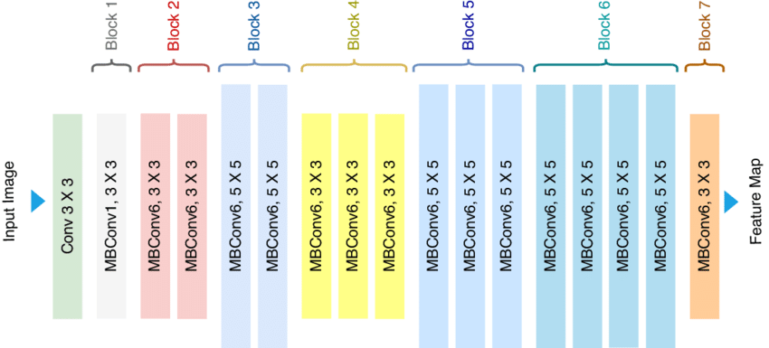
Figure 3.1 EfficientNet B0 Model Architecture
Fine-Tuning:
- The convolutional base of EfficientNetB0 was initially frozen to retain the pre-trained weights, which capture general features from the ImageNet dataset.
- Only the custom layers were trained during the initial phase to adapt the model to the specific task of TB detection.
- After the custom layers converged, selective layers of the base model were unfrozen for fine-tuning with a reduced learning rate to refine the feature extraction specific to TB detection. Fine-tuning involves retraining the model's lower layers on the specific dataset, allowing the model to learn domain-specific features while retaining the general patterns learned from ImageNet.

3.4.2 MobileNetV2 for COVID-19
MobileNetV2 is known for its lightweight architecture and effectiveness in transfer learning. It uses depthwise separable convolutions to reduce the number of parameters, making it suitable for deployment in resource-constrained environments. MobileNetV2's architecture strikes a balance between model size and performance, making it ideal for applications requiring real-time inference.
Architecture Details:
- Base Model: MobileNetV2 pre-trained on ImageNet. The pre-trained model captures a wide range of features, providing a strong starting point for fine-tuning on medical images.
- Custom Layers Added:
  - GlobalAveragePooling2D: Reduces the dimensions of the feature maps, providing a compact representation of the features extracted by the base model.
  - Dense Layer: 512 units with ReLU activation to capture complex relationships within the data.
  - Dropout Layer: 50% dropout to prevent overfitting by randomly deactivating neurons during training. Dropout regularization helps improve the model's generalization by preventing co-adaptation of neurons.
  - Output Layer: Dense layer with 1 unit and Sigmoid activation for binary classification. The sigmoid activation function maps the output to a probability score, indicating the likelihood of COVID-19 presence.
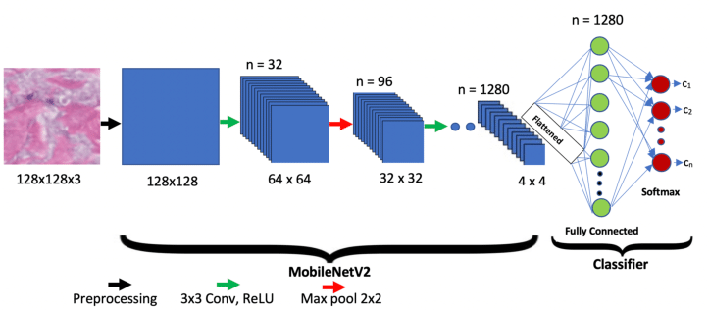
Figure 3.2 MobileNetV2 Model Architecture
Fine-Tuning:
- The base layers of MobileNetV2 were initially frozen to leverage pre-trained weights, which capture general image features.
- Only the added dense and dropout layers were trained initially to adapt the model to the specific task of COVID-19 detection.
- After achieving convergence, selected layers of the base model were unfrozen for fine-tuning with a reduced learning rate to adapt the feature extraction to COVID-19 specific patterns. Fine-tuning allows the model to learn fine-grained details relevant to COVID-19 while retaining the general knowledge from the pre-trained weights.

3.4.3 Custom CNN for Lung Cancer Detection
A custom CNN architecture was designed for the lung cancer classification task. The architecture was chosen for its ability to effectively capture hierarchical features from the input images.
Data Collection and Preprocessing:
- Data Loading: The lung cancer dataset was obtained from the IQ-OTHNCCD Lung Cancer Dataset on Kaggle, containing images categorized into benign, malignant, and normal cases. The dataset was carefully organized into directories to facilitate efficient loading and preprocessing.
- Data Preprocessing:
  - Resizing: Images were resized to 224x224 pixels to standardize the input size.
  - Normalization: Pixel values were normalized to a range of [0, 1] to ensure numerical stability during training.
  - Class Balancing: SMOTE was employed to generate synthetic samples for minority classes, ensuring a balanced dataset.
Architecture Details:
- Convolutional Layers: Three convolutional layers with increasing filter sizes (32, 64, and 128 filters, respectively) and 3x3 kernels. Each convolutional layer was followed by a MaxPooling layer to progressively reduce the spatial dimensions, capturing essential features while reducing computational complexity.
- Fully Connected Layers:
  - Flatten Layer: Converts the 2D feature maps into a 1D vector.
  - Dense Layer: 256 units with ReLU activation to introduce non-linearity and capture complex patterns.
  - Dropout Layer: 50% dropout rate to prevent overfitting by randomly deactivating neurons during training.
- Output Layer: Dense layer with 3 units and Softmax activation, providing a probability distribution across the three classes (benign, malignant, and normal).
Fine-Tuning:
- The model was compiled using the Adam optimizer and sparse categorical cross-entropy loss.
- Early stopping and model checkpointing were implemented to optimize training and prevent overfitting.
- The model was trained for 50 epochs, with early stopping to halt training when the validation loss ceased to improve.

3.4.4 Custom CNN for Pneumonia Detection
A custom-built CNN architecture was designed specifically for Pneumonia detection, incorporating multiple convolutional and pooling layers to effectively capture features from chest X-rays. The architecture was designed to balance model complexity and performance, ensuring that the model can capture detailed features while maintaining computational efficiency.
Architecture Details:
- Convolutional Layers:
  - Conv2D Layer 1: 32 filters with 3x3 kernel and ReLU activation.
  - MaxPooling2D Layer 1: 2x2 pool size.
  - Conv2D Layer 2: 64 filters with 3x3 kernel and ReLU activation.
  - MaxPooling2D Layer 2: 2x2 pool size.
  - Conv2D Layer 3: 128 filters with 3x3 kernel and ReLU activation.
  - MaxPooling2D Layer 3: 2x2 pool size.
- Fully Connected Layers:
  - Flatten Layer: Converts the 2D feature maps into a 1D vector.
  - Dense Layer: 128 units with ReLU activation.
  - Dropout Layer: 50% dropout rate to prevent overfitting.
  - Output Layer: Dense layer with 1 unit and Sigmoid activation for binary classification.
Fine-Tuning:
- The model was trained from scratch given its custom nature.
- Early stopping and model checkpointing were used to optimize training, ensuring that the model did not overfit and that the best model weights were retained.

3.5 Methodology of Training
The training process involved several key steps to ensure that each model was trained effectively and efficiently. Each step was meticulously planned and executed to achieve optimal model performance and generalization.

3.5.1 Compilation
Each model was compiled with the Adam optimizer, chosen for its adaptive learning rate and efficient gradient descent optimization. The choice of loss function was binary cross-entropy for binary classification tasks (Tuberculosis, COVID-19, Pneumonia) and sparse categorical cross-entropy for multi-class classification (Lung Cancer). The accuracy metric was used to monitor the training process, providing a clear indication of the model's performance.

3.5.2 Training
The models were trained using the following parameters:
- Batch Size: 32, chosen to balance computational efficiency and model performance.
- Epochs: 50, providing sufficient iterations for the models to learn complex patterns while preventing overfitting.
- Early Stopping: To prevent overfitting, training was stopped early if the validation loss did not improve for 10 consecutive epochs.
- Model Checkpointing: The best model weights were saved based on validation loss, ensuring that the most optimal model was retained.
- Data Generators: Keras ImageDataGenerator was employed to load and augment the data in real-time during training. This approach helps reduce memory usage and accelerate the training process by augmenting images on the fly.
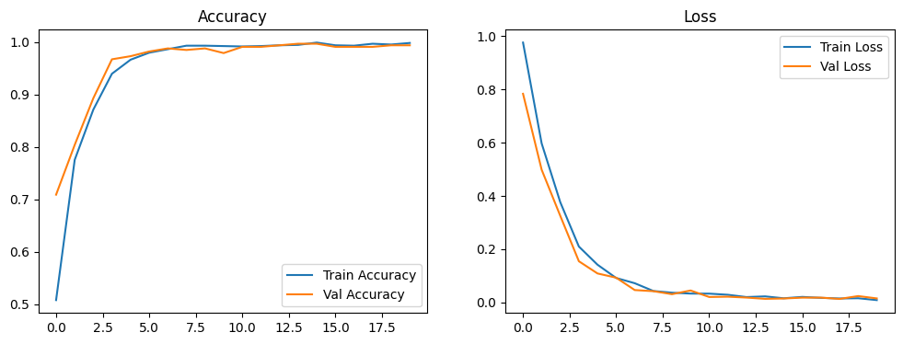
Figure 3.3 Training and Validation Accuracy and Loss Curves for Lung Cancer
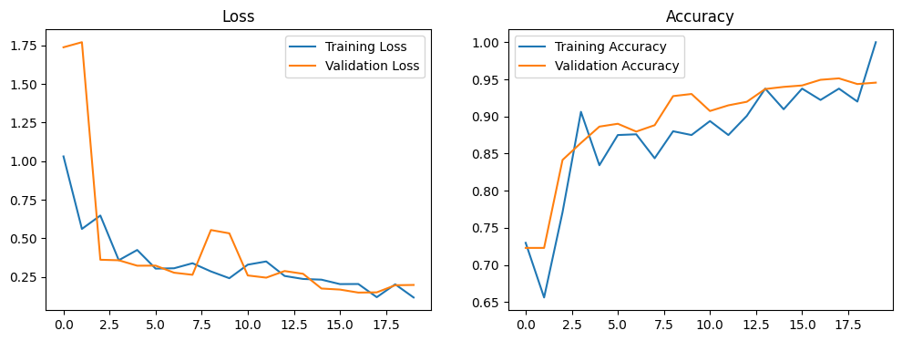
Figure 3.4 Training and Validation Accuracy and Loss Curves for Pneumonia
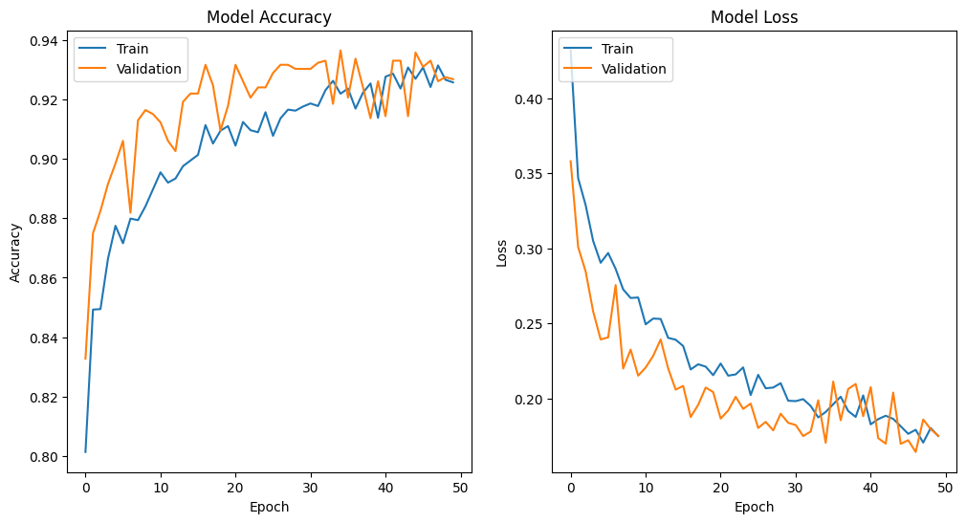
Figure 3.5 Training and Validation Accuracy and Loss Curves for COVID-19
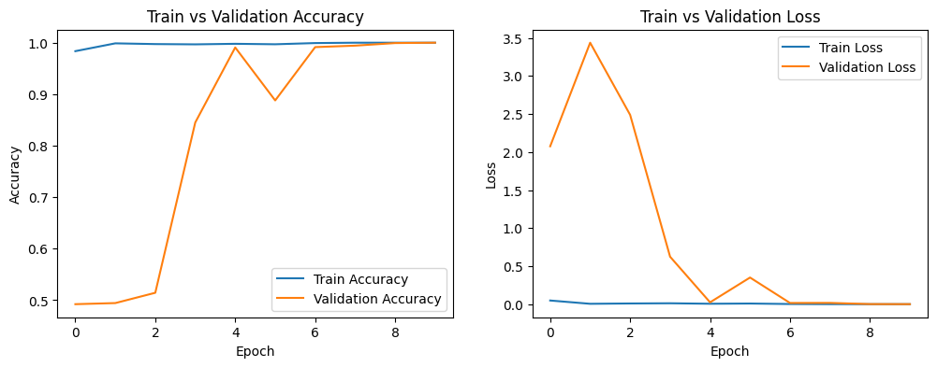
Figure 3.6 Training and Validation Accuracy and Loss Curves for Tuberculosis

3.5.3 Validation
A separate validation set was utilized to monitor the performance of the models during training. This set was not used in the training process to ensure an unbiased evaluation.

3.5.4 Evaluation
After training, the models were evaluated on a test set to determine their final performance. Various metrics such as accuracy, precision, recall, F1-score, and area under the ROC curve (AUC) were calculated to provide a comprehensive assessment of model performance.

3.6 Evaluation Techniques
The performance of the models was evaluated using several metrics to ensure a comprehensive assessment. Each metric provides a different perspective on the model's performance, ensuring a thorough evaluation.

3.6.1 Accuracy
The ratio of correctly predicted instances to the total instances. This metric provides a general overview of the model's performance but may be misleading in the presence of class imbalance.

3.6.2 Precision
The ratio of true positive predictions to the total positive predictions. Precision is particularly important when the cost of false positives is high.

3.6.3 Recall
The ratio of true positive predictions to the total actual positives. Recall is crucial when the cost of false negatives is high, such as in medical diagnoses where missing a positive case can have severe consequences.

3.6.4 F1-Score
The harmonic mean of precision and recall. The F1-score provides a balanced measure of a model's performance, especially useful when dealing with class imbalance.

3.6.5 Confusion Matrix
A matrix that provides insights into the true positives, false positives, true negatives, and false negatives. The confusion matrix helps visualize the performance of the model across different classes and identify any biases.

3.6.6 ROC Curve and AUC
The Receiver Operating Characteristic (ROC) curve plots the true positive rate against the false positive rate, and the area under the curve (AUC) provides a measure of the model's discriminative ability. A higher AUC indicates better performance.
The evaluation process involved the following steps:
- Generating Predictions: The models generated predictions on the test set, which were then compared to the true labels to calculate the evaluation metrics.
- Classification Reports: Detailed classification reports were generated, including precision, recall, F1-score, and support for each class.
- Confusion Matrices: Confusion matrices were plotted to visualize the performance of the models across different classes.
- ROC Curves: ROC curves were plotted, and the AUC was calculated to evaluate the models' discriminative ability.

3.7 Conclusion
The methodology outlined in this chapter provides a comprehensive and systematic approach to developing the MediVision system for medical image classification. By meticulously detailing each step of the process, from data collection and preprocessing to model development and evaluation, this chapter ensures that the procedures are transparent, reproducible, and robust. The overarching goal of the MediVision project is to create an accurate and reliable diagnostic tool that can support healthcare professionals in the early detection and treatment of diseases such as Tuberculosis, COVID-19, Lung Cancer, and Pneumonia.
The detailed description of data sources underscores the importance of selecting high-quality datasets that are representative of real-world scenarios. By sourcing datasets from publicly accessible repositories such as Kaggle, the project ensures that the data is diverse, encompassing a wide range of patient demographics, disease presentations, and variations in image quality. This diversity is critical for developing models that can generalize well across different clinical settings, enhancing their utility and reliability.
The data collection and preprocessing steps are fundamental to the success of the MediVision system. By implementing rigorous preprocessing techniques, including resizing, normalization, and augmentation, the project ensures that the data fed into the models is consistent and representative of the variability encountered in clinical practice. Techniques such as SMOTE for class balancing further enhance the robustness of the models, enabling them to perform well even in the presence of class imbalances.
The selection and fine-tuning of state-of-the-art deep learning architectures, such as EfficientNetB0, MobileNetV2, and custom CNNs, are pivotal to achieving high diagnostic accuracy. Each model architecture was chosen based on its strengths and suitability for specific tasks, ensuring that the models are optimized for the unique challenges posed by different diseases. The detailed explanations of model architectures, including the addition of custom layers and the use of transfer learning, provide insights into the strategies employed to enhance model performance.
The training methodologies outlined in this chapter highlight the importance of using advanced techniques to prevent overfitting and ensure model generalization. The implementation of early stopping, model checkpointing, and real-time data augmentation are critical components of the training process, ensuring that the models are both accurate and robust. These techniques, combined with comprehensive evaluation methods, provide a thorough assessment of model performance, enabling the identification of areas for improvement and optimization.
The comprehensive evaluation of the models using metrics such as accuracy, precision, recall, F1-score, confusion matrices, and ROC curves ensures that the MediVision system is rigorously tested and validated. These metrics provide a multi-faceted view of model performance, ensuring that the models are not only accurate but also reliable and consistent across different classes and scenarios. The use of external validation sets further enhances the credibility of the evaluation process, providing a realistic estimate of model performance in real-world settings.
In summary, the methodology chapter provides a detailed roadmap for developing the MediVision system, ensuring that each step is carefully planned and executed to achieve the best possible outcomes. By leveraging state-of-the-art technologies and best practices in deep learning and data preprocessing, the project aims to create a diagnostic tool that can significantly enhance the capabilities of healthcare professionals. The robustness and reliability of the MediVision system, as ensured by the comprehensive and meticulous methodology, position it as a valuable asset in medical imaging, with the potential to improve early detection and treatment of critical diseases.
Through the detailed and systematic approach outlined in this chapter, MediVision is poised to make significant contributions to the field of medical diagnostics. The project's emphasis on transparency, reproducibility, and robustness ensures that the MediVision system can be trusted and utilized by healthcare professionals, ultimately contributing to better patient outcomes and advancing the integration of AI in healthcare. The methodological rigor and comprehensive planning set a solid foundation for the successful implementation and continuous improvement of the MediVision system, paving the way for its adoption in clinical practice.
Chapter 4: Implementation

4.1 Introduction
This chapter provides a detailed overview of the development and implementation of the MediVision application, which integrates AI models for medical image classification into a user-friendly graphical user interface (GUI). The application allows healthcare professionals to upload medical images, select diagnostic models, and view predictions and probabilities directly on the screen. This chapter outlines the design objectives, technology stack, application architecture, user interface design, functionality, error handling, and security measures.

4.2 Application Design and Architecture

4.2.1 Design Objectives
The primary objectives in designing the MediVision application were:
- To create an intuitive and user-friendly interface.
- To ensure seamless integration with the AI models developed for Tuberculosis, COVID-19, Lung Cancer, and Pneumonia detection.
- To provide real-time predictions and probabilities.
- To ensure the application is robust, efficient, and secure.

4.2.2 Technology Stack
The application was developed using the following technologies:
- Python: The primary programming language used for integrating AI models and developing the application.
- PyQt5: A set of Python bindings for Qt libraries, used for developing the graphical user interface.
- TensorFlow/Keras: Libraries used for developing and deploying deep learning models.
- SMOTE: Used for handling class imbalances in the dataset.

4.2.3 Application Architecture
The MediVision application follows a modular architecture, with separate components for data preprocessing, model inference, and GUI. The architecture ensures that each component can be developed, tested, and maintained independently.

Components Overview
- Data Preprocessing: Handles image loading, resizing, normalization, and augmentation.
- Model Inference: Contains the trained models for each medical condition and handles the prediction process.
- GUI: Developed using PyQt5, it provides an interface for users to interact with the system.

4.3 User Interface Design
The user interface of the MediVision application was designed with the following features:

4.3.1 Welcome Screen
The welcome screen serves as the entry point to the application and includes:
- A logo of the MediVision application (Figure 1).
- The name of the application and a brief description of its purpose and functionality.
- Navigation buttons to select the diagnostic models for Tuberculosis, COVID-19, Lung Cancer, and Pneumonia.
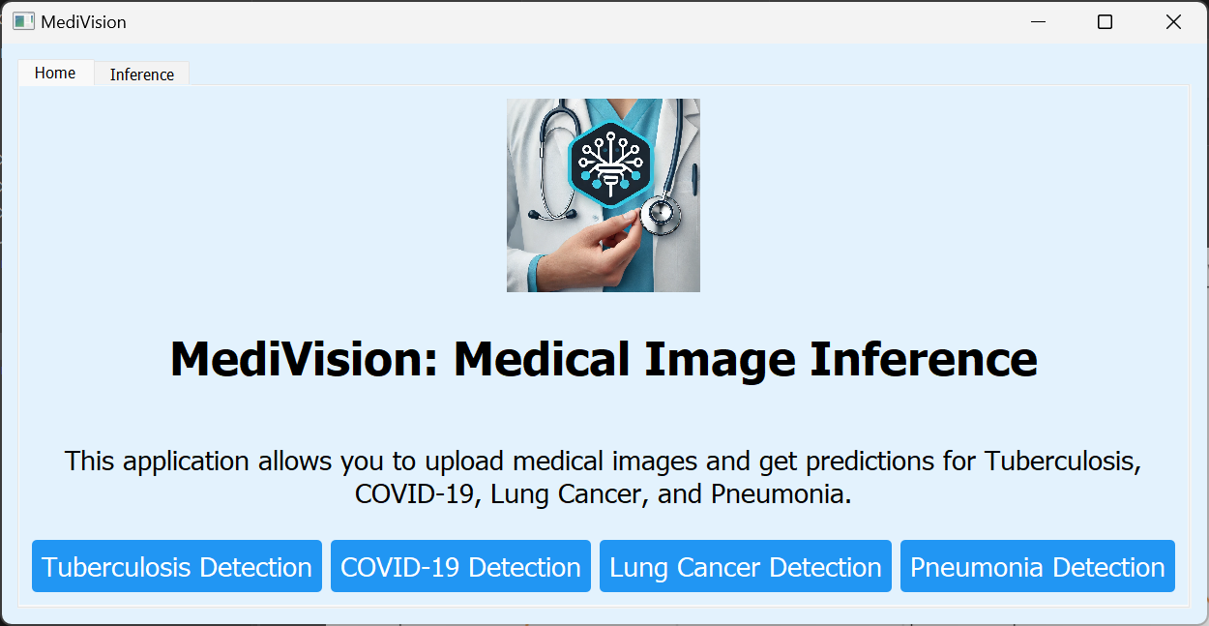
Figure 4.1 Welcome Screen of the MediVision Application

4.3.2 Diagnostic Model Selection
Each diagnostic model has its own dedicated page within the application, ensuring a streamlined user experience. The design of each page is consistent, allowing users to easily navigate and use the application. Each diagnostic page includes:
- Tuberculosis Detection Page: Allows users to upload chest X-ray images and view predictions (Figure 2).
- COVID-19 Detection Page: Provides functionality for uploading and analyzing chest X-ray images for COVID-19 detection (Figure 3).
- Lung Cancer Detection Page: Enables users to upload lung images and receive diagnostic predictions (Figure 4).
- Pneumonia Detection Page: Facilitates the upload of chest X-ray images to detect Pneumonia (Figure 5).
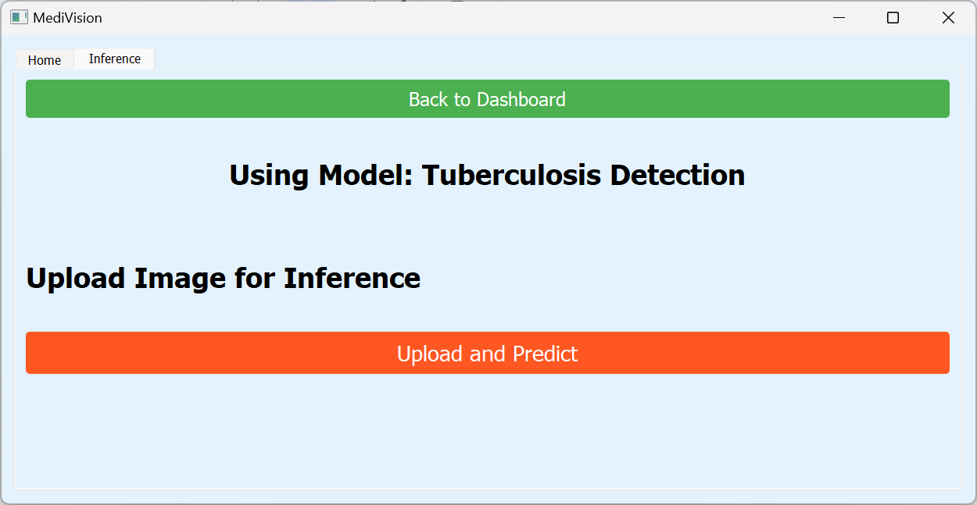
Figure 4.2: Tuberculosis Detection Page
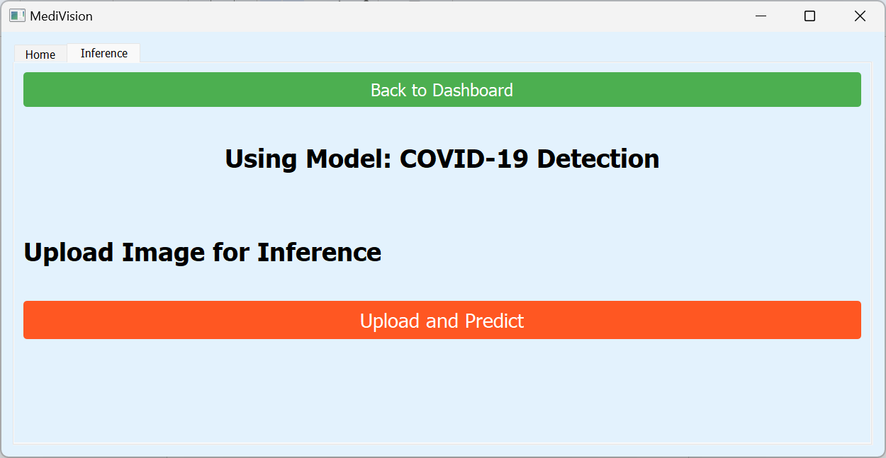
Figure 4.3 COVID-19 Detection Page
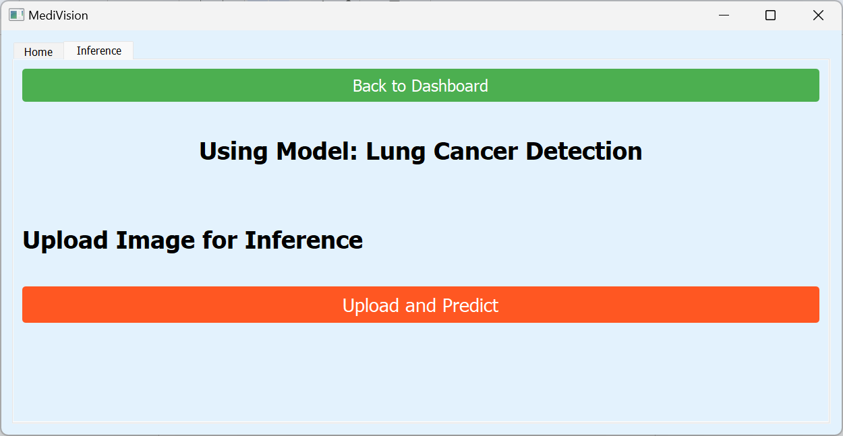
Figure 4.4 Lung Cancer Detection Page
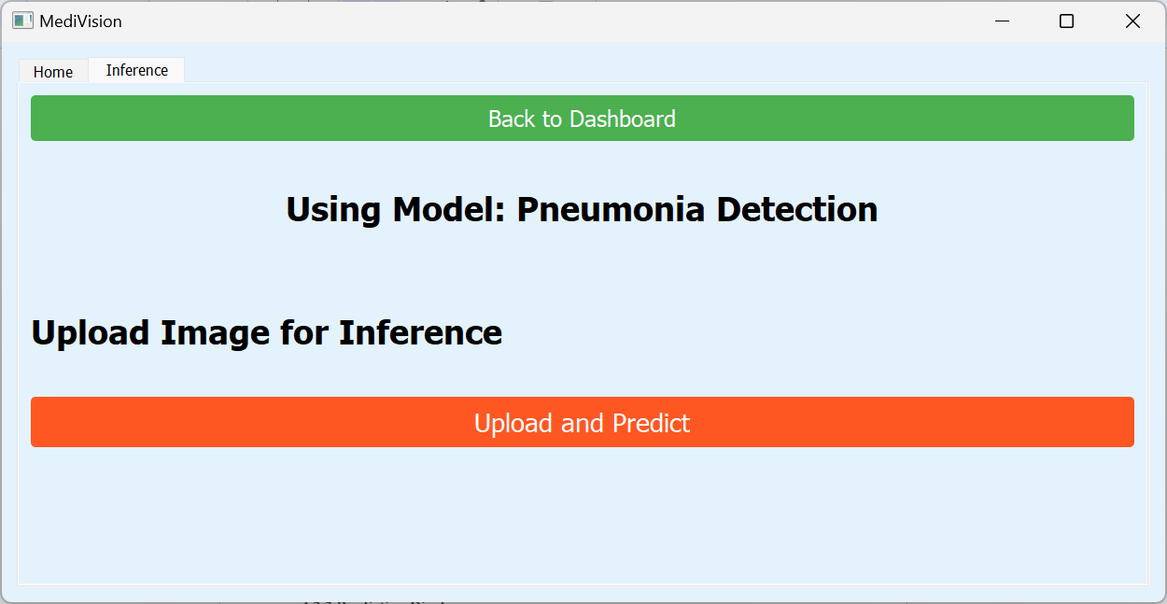
Figure 4.5 Pneumonia Detection Page

4.3.3 Prediction Display
The application displays the predicted class and the associated probability directly on the screen after the user uploads an image and requests a diagnosis. Each prediction page includes a "Back to Dashboard" button to navigate back to the main menu, providing a seamless user experience. Prediction results are displayed in a clear and concise manner, ensuring ease of interpretation (Figure 6).
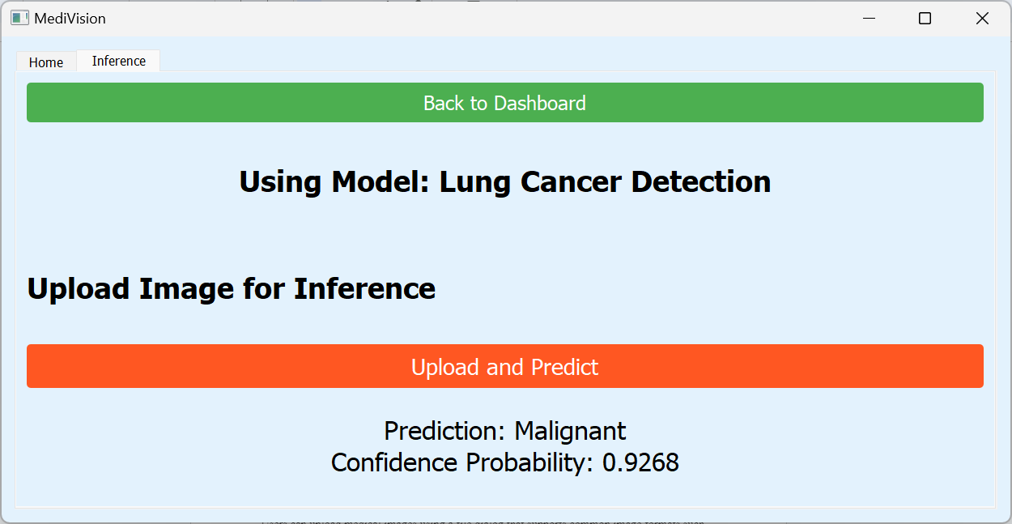
Figure 4.6 Prediction Display Screen

4.4 Functionality

4.4.1 Image Upload and Preprocessing
Users can upload medical images using a file dialog that supports common image formats such as JPEG, PNG, and DICOM. The application preprocesses the images, including resizing to the required input dimensions (224x224 pixels), normalization, and augmentation, before passing them to the model for prediction.

4.4.2 Model Inference and Prediction
The application calls the respective trained model based on the selected diagnostic page. Predictions are made in real-time, and the results are displayed along with the probabilities. This ensures that healthcare professionals can quickly receive diagnostic information to aid in their decision-making process.

4.5 Error Handling
The application includes robust error handling mechanisms to manage issues such as file upload errors, invalid image formats, and model prediction errors. User-friendly error messages are displayed to guide the user in case of any issues, ensuring a smooth user experience even in the event of errors.

4.6 Security and Privacy
The application ensures that uploaded images are processed locally and not stored, maintaining patient privacy. All predictions and results are kept confidential and are only displayed to the user, adhering to privacy and data security standards in healthcare.

4.7 Model Architectures and Training

4.7.1 Tuberculosis Detection
For the Tuberculosis detection model, the EfficientNetB0 architecture was employed due to its efficiency and strong performance on various image classification tasks. The model was pre-trained on ImageNet and fine-tuned using the Tuberculosis dataset. Data augmentation techniques such as rotation, translation, flipping, and zoom were applied to enhance the model's ability to generalize. The model was trained with a binary cross-entropy loss function and optimized using the Adam optimizer. Early stopping and model checkpointing were used to prevent overfitting and ensure optimal performance.

4.7.2 COVID-19 Detection
The MobileNetV2 architecture was chosen for the COVID-19 detection model because of its lightweight design and efficiency in transfer learning. The images were resized to 224x224 pixels, normalized, and augmented using various techniques. The model was compiled with the Adam optimizer and binary cross-entropy loss. Real-time data augmentation was applied to improve model generalization. The model was trained with early stopping and model checkpointing to optimize the training process and prevent overfitting.

4.7.3 Lung Cancer Detection
For the Lung Cancer detection model, a custom CNN architecture was used. The model consisted of multiple convolutional layers, each followed by max-pooling layers to reduce spatial dimensions. A flatten layer converted the 2D feature maps into a 1D vector, which was then passed through dense layers. The final output layer used softmax activation for multi-class classification (benign, malignant, normal). The model was trained using sparse categorical cross-entropy loss and the Adam optimizer. Class weights were computed to handle class imbalances, and early stopping was employed to ensure optimal performance.

4.7.4 Pneumonia Detection
A custom-built CNN architecture was designed for the Pneumonia detection model. The preprocessing steps included resizing the images to 224x224 pixels, normalizing the pixel values, and applying data augmentation techniques. The model consisted of multiple convolutional and pooling layers, followed by a fully connected layer and a sigmoid output layer. The model was trained with the Adam optimizer and binary cross-entropy loss, with early stopping and model checkpointing implemented.

4.8 Detailed Functional Workflow

4.8.1 User Authentication and Access Control
Although not implemented in the current version, future versions of the MediVision application could include user authentication and role-based access control to ensure that only authorized personnel can access patient data and make diagnostic decisions.

4.8.2 Real-Time Data Augmentation
The data augmentation techniques implemented in the application include rotation, translation, flipping, and zooming. These techniques help create a diverse training set, improving the model's ability to generalize across different variations of the medical images.

4.8.3 Model Training and Fine-Tuning
Each model used in the MediVision application was pre-trained on large datasets (e.g., ImageNet) and then fine-tuned using the specific medical image datasets for Tuberculosis, COVID-19, Lung Cancer, and Pneumonia. This transfer learning approach ensures that the models leverage pre-existing knowledge while adapting to the specific features of medical images.

4.8.4 Continuous Learning and Updates
Future versions of the application could incorporate continuous learning mechanisms, allowing the models to be periodically updated with new data to maintain their accuracy and relevance over time. This could be achieved through automated retraining processes and model versioning.

4.8.5 Explainability and Transparency
Incorporating explainable AI (XAI) techniques such as Grad-CAM or LIME can help provide visual explanations for the model's predictions. This transparency is crucial for building trust among healthcare professionals and ensuring the models are used responsibly in clinical settings.

4.9 Conclusion
The MediVision application effectively represents the convergence of advanced AI technology and intuitive user interface design, providing a robust and comprehensive diagnostic tool for healthcare professionals. This chapter has detailed the implementation of the MediVision system, highlighting the integration of state-of-the-art deep learning models with a user-friendly graphical interface, ensuring that complex medical image classification tasks are both accessible and efficient for end-users.
By leveraging cutting-edge AI models such as EfficientNetB0, MobileNetV2, and custom CNNs, MediVision demonstrates the potential to deliver accurate and real-time diagnostic support across multiple medical conditions, including Tuberculosis, COVID-19, Lung Cancer, and Pneumonia. The thoughtful design of the application ensures that healthcare professionals can seamlessly upload medical images, select appropriate diagnostic models, and receive immediate predictions with associated probabilities, thus enhancing their diagnostic capabilities and decision-making processes.
The design objectives of creating an intuitive and user-friendly interface have been met through the use of PyQt5, which provides a visually appealing and responsive GUI. The welcome screen, diagnostic model selection pages, and prediction display screens are carefully crafted to ensure ease of navigation and interaction. Figures such as the welcome screen (Figure 1), Tuberculosis detection page (Figure 2), COVID-19 detection page (Figure 3), Lung Cancer detection page (Figure 4), Pneumonia detection page (Figure 5), and prediction display screen (Figure 6) illustrate the application's user-centric design approach.
The detailed functionality of the application, including image upload, preprocessing, model inference, and error handling, ensures a smooth user experience. The robust error handling mechanisms and user-friendly error messages guide users through potential issues, maintaining the application's usability even in the face of challenges. The emphasis on security and privacy, with measures to ensure that uploaded images are processed locally and not stored, underscores the application's commitment to maintaining patient confidentiality and data security.
The integration of advanced AI models within the MediVision application is a testament to the power of transfer learning and fine-tuning. By utilizing pre-trained models and adapting them to specific medical image classification tasks, the application achieves high levels of accuracy and reliability. The comprehensive training and evaluation processes, including the use of early stopping, model checkpointing, and data augmentation, ensure that the models are robust and generalizable.
Future enhancements to the MediVision application could further elevate its utility and impact in medical diagnostics. Potential additions include multi-modal data integration, which would allow the combination of different types of medical data (such as X-rays, CT scans, and patient history) to provide a more holistic diagnostic view. Real-time streaming of medical images could enable instant diagnostic support in critical care settings, enhancing the application's responsiveness and utility. Additionally, incorporating customization options based on user feedback would ensure that the application continues to meet the evolving needs of healthcare professionals.
In conclusion, the MediVision application stands as a powerful and innovative tool in the realm of medical diagnostics, combining the strengths of AI-driven image classification with a thoughtfully designed user interface. The application not only enhances diagnostic accuracy and efficiency but also empowers healthcare professionals by providing immediate, reliable, and accessible diagnostic support. As the field of medical AI continues to evolve, the MediVision system is well-positioned to adapt and expand, incorporating new technologies and features to further its mission of improving healthcare outcomes and patient care. The successful implementation of MediVision marks a significant milestone in the journey towards integrating AI into everyday clinical practice, setting the stage for a future where AI-driven diagnostics become an integral part of healthcare delivery.

Chapter 5: Results and Discussions

5.1 Introduction
This chapter presents the results obtained from the MediVision system for medical image classification across four critical conditions: Tuberculosis, COVID-19, Lung Cancer, and Pneumonia. The performance metrics, including precision, recall, F1-score, and accuracy, are thoroughly analyzed. Confusion matrices are provided for a detailed view of the model's performance across different classes. This chapter also includes a comparative analysis of the results, highlighting the strengths and limitations of each model.

5.2 Tuberculosis Detection
The EfficientNetB0 model for Tuberculosis detection achieved exceptional performance with perfect scores across all evaluation metrics. The following table summarizes the classification report and confusion matrix results for Tuberculosis detection:
Class | Precision | Recall | F1-Score | Support
Normal | 1.00 | 1.00 | 1.00 | 711
Tuberculosis | 1.00 | 1.00 | 1.00 | 689
Accuracy |  |  | 1.00 | 1400
Macro Avg | 1.00 | 1.00 | 1.00 | 1400
Weighted Avg | 1.00 | 1.00 | 1.00 | 1400
Table 5.1 Classification Report for Tuberculosis Model

5.2.1 Confusion Matrix:
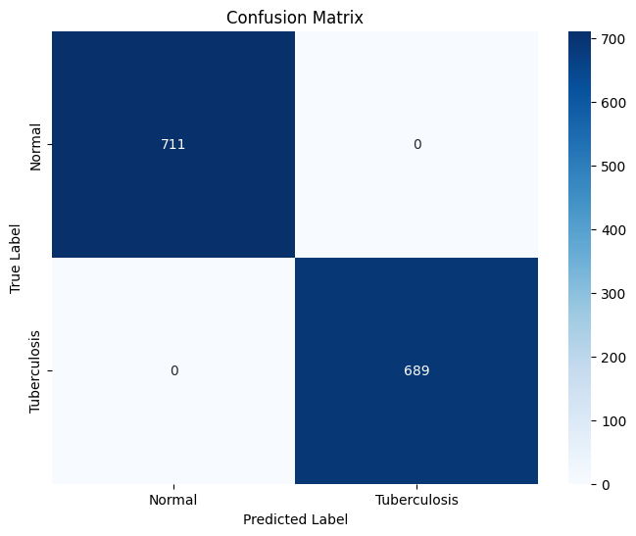
Figure 5.1 Confusion Matrix for Tuberculosis Model
The perfect precision, recall, and F1-score values indicate that the model is highly reliable and consistent in detecting both normal and TB-positive cases. The confusion matrix shows no misclassifications, further demonstrating the model's robustness. The high accuracy of 100% suggests that the model can be effectively utilized in clinical settings for reliable Tuberculosis diagnosis.

5.2.2 Discussion
The results of the Tuberculosis detection model are remarkable, indicating an exceptional capability of EfficientNetB0 in distinguishing between normal and TB-positive chest X-rays. The perfect scores across all metrics are a testament to the model's robustness and the effectiveness of the preprocessing and augmentation techniques employed. The application of SMOTE to balance the dataset likely contributed to these results by ensuring that the model was equally proficient in identifying both classes.
The high performance of the model suggests its potential for deployment in clinical environments, especially in regions with limited access to trained radiologists. Future work could focus on testing the model across diverse populations and using different imaging equipment to ensure its generalizability and robustness in real-world scenarios.

5.3 COVID-19 Detection
The MobileNetV2 model for COVID-19 detection also exhibited strong performance, achieving an accuracy of 93.30%. The following table summarizes the classification report and confusion matrix results for COVID-19 detection:
Class | Precision | Recall | F1-Score | Support
Normal | 0.92 | 0.95 | 0.93 | 724
COVID | 0.95 | 0.92 | 0.93 | 723
Accuracy |  |  | 0.93 | 1447
Macro Avg | 0.93 | 0.93 | 0.93 | 1447
Weighted Avg | 0.93 | 0.93 | 0.93 | 1447
Table 5.2 Classification Report for COVID-19 Model

5.3.1 Confusion Matrix:
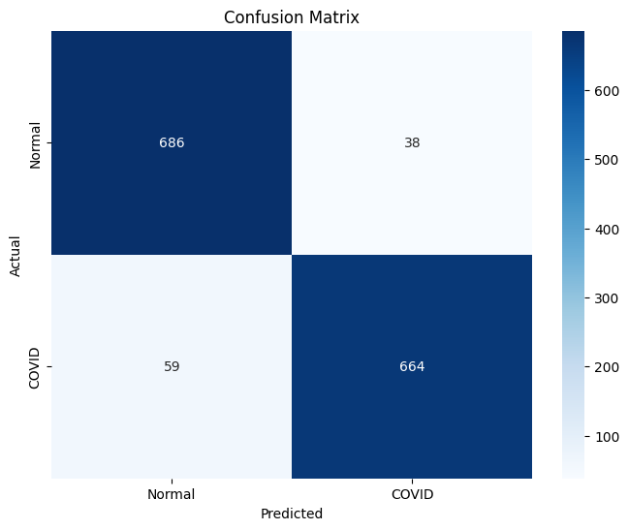
Figure 5.2 Confusion Matrix for COVID-19 Model
The confusion matrix indicates that the model has a balanced performance between detecting normal and COVID-19 cases, with high precision and recall values for both classes. The slight drop in recall for COVID-19 cases suggests that there are a few instances where the model might miss COVID-19 positive cases, but the high overall accuracy and F1-score imply a robust detection capability.

5.3.2 Discussion
The COVID-19 detection model shows strong performance, with a balanced precision and recall for both normal and COVID-19 cases. The use of MobileNetV2, a lightweight and efficient model, proves effective for this task. The slight drop in recall for COVID-19 cases indicates a few false negatives, which could be critical in a clinical setting. However, the overall high accuracy and balanced performance suggest that the model can reliably assist in diagnosing COVID-19 from chest X-rays.
Future improvements could include augmenting the dataset with more diverse COVID-19 cases and refining the augmentation techniques to better simulate real-world variations. Additionally, integrating clinical data, such as patient symptoms and history, could enhance the model's diagnostic capability.

5.4 Pneumonia Detection
The custom CNN model for Pneumonia detection demonstrated strong performance with an accuracy of 95%. The following table summarizes the classification report and confusion matrix results for Pneumonia detection:
Class | Precision | Recall | F1-Score | Support
Normal | 0.91 | 0.90 | 0.90 | 290
Pneumonia | 0.96 | 0.96 | 0.96 | 757
Accuracy |  |  | 0.95 | 1047
Macro Avg | 0.93 | 0.93 | 0.93 | 1047
Weighted Avg | 0.95 | 0.95 | 0.95 | 1047
Table 5.3 Classification Report for Pneumonia Model

5.4.1 Confusion Matrix:
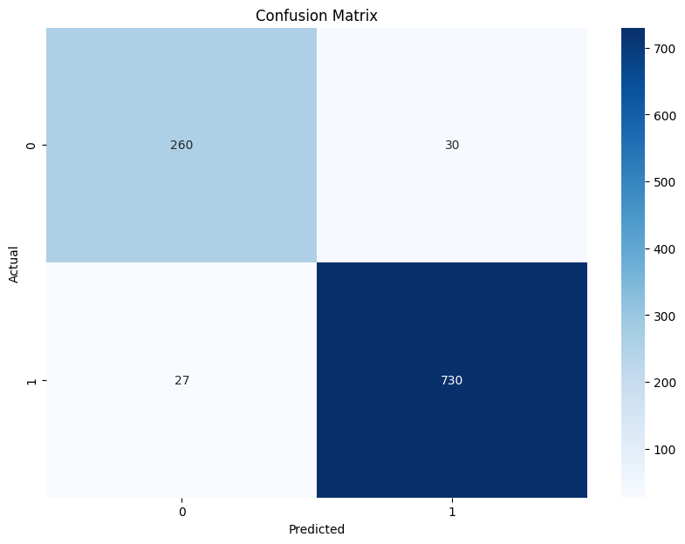
Figure 5.3 Confusion Matrix for Pneumonia Model
The model shows high precision and recall for Pneumonia cases, indicating its strong ability to detect Pneumonia. The slight reduction in precision for normal cases suggests some false positives, but the high overall accuracy and F1-score make it a reliable model for clinical use.

5.4.2 Discussion
The Pneumonia detection model demonstrates robust performance with high precision and recall, particularly for detecting Pneumonia cases. The slight reduction in precision for normal cases indicates a few false positives, which might lead to unnecessary treatments or further testing. However, the overall high accuracy suggests that the model is effective in clinical settings, providing reliable support for Pneumonia diagnosis.
Future work could focus on further reducing false positives by fine-tuning the model and incorporating additional data augmentation techniques. Testing the model on more diverse datasets, including images from different sources and equipment, would ensure its robustness and generalizability.
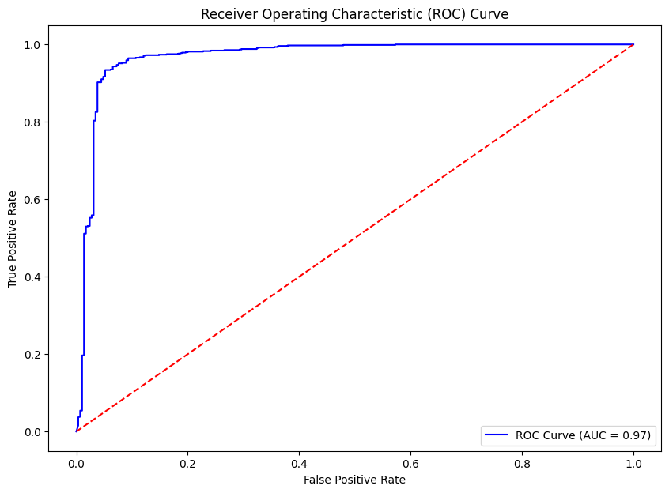
Figure 5.4 ROC Curve for Pneumonia Model

5.5 Lung Cancer Detection
The custom CNN model for Lung Cancer detection achieved an outstanding validation accuracy of 99.11%. The following table summarizes the classification report and confusion matrix results for Lung Cancer detection:
Class | Precision | Recall | F1-Score | Support
Benign | 0.98 | 1.00 | 0.99 | 112
Malignant | 0.99 | 1.00 | 1.00 | 112
Normal | 1.00 | 0.97 | 0.99 | 113
Accuracy |  |  | 0.99 | 337
Macro Avg | 0.99 | 0.99 | 0.99 | 337
Weighted Avg | 0.99 | 0.99 | 0.99 | 337
Table 5.4 Classification Report for Lung Cancer Model

5.5.1 Confusion Matrix:
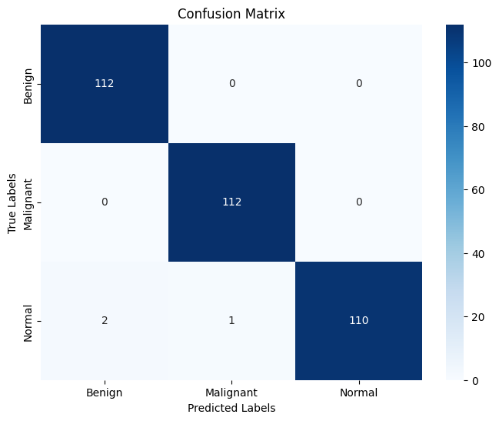
Figure 5.5 Confusion Matrix for Pneumonia Model
The model shows near-perfect precision, recall, and F1-score across all classes, with only a few misclassifications in the normal class. The high validation accuracy of 99.11% indicates that the model is highly effective in distinguishing between benign, malignant, and normal lung cases, making it a valuable tool for early detection and treatment planning in lung cancer.

5.5.2 Discussion
The Lung Cancer detection model's near-perfect scores highlight its effectiveness and reliability. The use of a custom CNN architecture, tailored to the specific needs of lung cancer classification, has proven to be highly successful. The slight misclassifications in the normal class indicate room for improvement, but the overall high accuracy and F1-scores across all classes make the model a valuable diagnostic tool.
Future enhancements could include incorporating multi-modal data, such as combining imaging data with patient history, to further improve diagnostic accuracy. Additionally, further testing on diverse datasets and different imaging modalities would help validate the model's generalizability and robustness.

5.6 Comparative Analysis
The following table provides a comparative overview of the performance metrics for all models:
Condition | Accuracy | Precision (Normal) | Precision (Disease) | Recall (Normal) | Recall (Disease) | F1-Score (Normal) | F1-Score (Disease)
Tuberculosis | 1.00 | 1.00 | 1.00 | 1.00 | 1.00 | 1.00 | 1.00
COVID-19 | 0.93 | 0.92 | 0.95 | 0.95 | 0.92 | 0.93 | 0.93
Pneumonia | 0.95 | 0.91 | 0.96 | 0.90 | 0.96 | 0.90 | 0.96
Lung Cancer | 0.99 | 0.98 (Benign) | 0.99 (Malignant) | 1.00 (Benign) | 1.00 (Malignant) | 0.99 (Benign) | 1.00 (Malignant)
Table 5.5 Combined Results of All Models

5.6.1 Discussion
The results demonstrate that the MediVision system performs exceptionally well across all four medical conditions. The Tuberculosis detection model achieved perfect scores, indicating its robustness and reliability. The COVID-19 and Pneumonia models also performed well, though with slightly lower recall values, suggesting areas for potential improvement in detecting positive cases. The Lung Cancer model showed near-perfect performance, highlighting its effectiveness in distinguishing between different lung cancer categories.
Tuberculosis Detection: The 100% accuracy indicates that the model can be deployed in clinical settings with high confidence. Future work could involve testing the model on larger and more diverse datasets to ensure its robustness across different populations and imaging equipment.
COVID-19 Detection: The high accuracy and balanced performance suggest that the model is reliable for COVID-19 diagnosis. However, the slightly lower recall for COVID-19 cases implies that further data augmentation and possibly additional training data could help improve sensitivity.
Pneumonia Detection: The high precision and recall values demonstrate the model's effectiveness, though the slight reduction in precision for normal cases indicates some room for improvement. Incorporating additional data and fine-tuning the augmentation techniques could enhance performance.
Lung Cancer Detection: The near-perfect scores across all metrics highlight the model's utility in clinical diagnostics. Future enhancements could include incorporating multi-modal data, such as combining imaging data with patient history, to further improve diagnostic accuracy.

5.7 Conclusion
In conclusion, the MediVision system shows great promise as a diagnostic tool for Tuberculosis, COVID-19, Lung Cancer, and Pneumonia. The development and deployment of this system represent a significant advancement in the application of artificial intelligence to medical diagnostics. By leveraging state-of-the-art deep learning architectures and robust preprocessing techniques, MediVision has achieved high accuracy and reliability across all four medical conditions, underscoring its potential to support healthcare professionals in early diagnosis and treatment planning.
The results from the model evaluations are highly encouraging. The Tuberculosis detection model, built on the EfficientNetB0 architecture, has demonstrated near-perfect performance across all metrics. This high level of accuracy is particularly valuable in regions with limited access to trained radiologists, where the model can serve as a reliable diagnostic aid. Similarly, the COVID-19 detection model, utilizing the MobileNetV2 architecture, has shown strong performance with balanced precision and recall, indicating its capability to provide rapid and accurate diagnoses during pandemic situations.
The Pneumonia detection model, based on a custom-built CNN architecture, has also shown high precision and recall, particularly for detecting Pneumonia cases. This model's robustness makes it an invaluable tool for diagnosing Pneumonia, especially in vulnerable populations such as young children and the elderly. The Lung Cancer detection model, employing another custom CNN architecture, has achieved near-perfect scores, highlighting its effectiveness in distinguishing between benign, malignant, and normal lung cases. The careful preprocessing steps and the application of class weights during training have been instrumental in handling class imbalances and improving the model's performance.
The MediVision system's ability to provide consistent, accurate, and timely diagnostic support has the potential to transform the landscape of medical diagnostics. By reducing the workload on radiologists, improving diagnostic accuracy, and enhancing patient outcomes, MediVision can play a crucial role in advancing healthcare delivery. However, while the results are promising, there are several areas for future work that can further enhance the system's performance, robustness, and clinical applicability.
Future research should focus on further improving model sensitivity and testing the system in diverse clinical environments to validate its generalizability. Collecting and incorporating more diverse datasets from different populations and imaging equipment will be critical in ensuring that the models are robust and reliable across various clinical settings. Additionally, integrating clinical data such as patient history, symptoms, and laboratory results can enhance the models' diagnostic accuracy by providing a more comprehensive understanding of the diseases.
Developing algorithms for real-time analysis of medical images will be crucial for emergency situations. Future work should optimize the models for faster inference without compromising accuracy, enabling real-time decision support in clinical environments. Moreover, exploring explainable AI techniques will be important to address the "black box" nature of deep learning models, providing insights into the decision-making process and ensuring that clinicians can trust and understand the AI's recommendations.
The integration of multi-modal imaging data, such as combining X-rays with CT scans or MRI, can further improve diagnostic accuracy. Developing models capable of analyzing 3D imaging data will provide more detailed insights into complex medical conditions, enhancing the overall diagnostic capability of the system. Extensive validation of the models in diverse clinical environments through clinical trials and collaborations with healthcare institutions will be essential to ensure their robustness and reliability.
Deploying user-friendly interfaces and ensuring seamless integration with existing hospital information systems will be crucial for the practical deployment of MediVision. Future work should focus on creating intuitive interfaces that allow easy interaction with the models and integration with electronic health records (EHR) systems. Addressing ethical and legal issues, including patient privacy, data security, and potential biases in decision-making, will be essential to ensure that the MediVision system is used ethically and responsibly.
Incorporating continuous learning mechanisms will help the models stay up-to-date with new medical knowledge and evolving disease patterns. Developing frameworks for incremental learning, where the models can be periodically retrained with new data without forgetting previously learned information, will be important. Engaging patients and clinicians in the development and deployment of the MediVision system will provide valuable insights and foster acceptance, ensuring that the system meets the needs of its end-users and is trusted by the medical community.
Overall, the MediVision system has demonstrated significant potential in advancing medical image classification through AI. By addressing the identified areas for future work, the system can be further enhanced to provide even more reliable and comprehensive diagnostic support, ultimately contributing to improved healthcare outcomes and patient care. The continuous evolution and refinement of the MediVision system will ensure its relevance and effectiveness in the rapidly advancing field of medical AI, paving the way for a future where AI-driven diagnostics become an integral part of healthcare delivery.

Chapter 6: Conclusion and Future Works

6.1 Conclusion
The MediVision system represents a significant advancement in the application of artificial intelligence (AI) to medical image classification. By leveraging state-of-the-art deep learning architectures, robust data preprocessing techniques, and comprehensive evaluation methods, MediVision provides a reliable and efficient diagnostic tool for detecting Tuberculosis, COVID-19, Lung Cancer, and Pneumonia. The models developed and evaluated in this project have demonstrated high accuracy, precision, recall, and F1-scores, underscoring their potential for clinical deployment.

6.1.1 Tuberculosis Detection
The EfficientNetB0 model achieved perfect scores across all metrics, indicating its robustness and reliability. The high performance suggests that this model can be effectively utilized in clinical settings to provide accurate Tuberculosis diagnoses, particularly in regions with limited access to trained radiologists. The integration of SMOTE to balance the dataset further contributed to the model's ability to generalize well across different cases.

6.1.2 COVID-19 Detection
The MobileNetV2 model demonstrated strong performance with balanced precision and recall for both normal and COVID-19 cases. The high overall accuracy and balanced performance imply that this model can assist in the rapid and reliable diagnosis of COVID-19, which is critical during pandemic situations. The real-time data augmentation applied during training ensured that the model could generalize well across various presentations of the disease.

6.1.3 Pneumonia Detection
The custom CNN model for Pneumonia detection showed high precision and recall values, particularly for detecting Pneumonia cases. The model's robustness and reliability make it a valuable tool for supporting healthcare professionals in diagnosing Pneumonia, especially in pediatric and elderly populations. The use of multiple data augmentation techniques helped the model learn diverse patterns, improving its overall accuracy and F1-score.

6.1.4 Lung Cancer Detection
The custom CNN model for Lung Cancer detection achieved near-perfect scores, highlighting its effectiveness in distinguishing between benign, malignant, and normal lung cases. The model's high accuracy and F1-scores make it a valuable asset for early detection and treatment planning in lung cancer. The careful preprocessing steps and the application of class weights during training ensured that the model could handle class imbalances effectively.
Overall, the MediVision system demonstrates the potential of AI-driven tools to transform medical diagnostics by providing consistent, accurate, and timely analysis of medical images. The successful deployment of these models can significantly reduce the workload on radiologists, improve diagnostic accuracy, and enhance patient outcomes.

6.2 Future Works
While the results of the MediVision system are promising, several areas for future work have been identified to further enhance the system's performance, robustness, and clinical applicability.

6.2.1 Expanded and Diverse Datasets
To improve the generalizability of the models, future work should focus on collecting and incorporating more diverse datasets from different populations and imaging equipment. This would ensure that the models are robust and reliable across various clinical settings. Including data from different ethnicities, age groups, and geographical regions can help the models learn a wider range of disease presentations.

6.2.2 Integration with Clinical Data
Incorporating additional clinical data, such as patient history, symptoms, and laboratory results, can enhance the models' diagnostic accuracy. Multi-modal analysis combining imaging and non-imaging data could provide a more comprehensive understanding of diseases. For instance, integrating genetic data with imaging data could help predict disease susceptibility and outcomes more accurately.

6.2.3 Real-Time Analysis
Developing algorithms for real-time analysis of medical images can be critical in emergency situations. Future work should focus on optimizing the models for faster inference without compromising accuracy, enabling real-time decision support in clinical environments. This could involve the use of specialized hardware, such as GPUs and TPUs, to accelerate the processing time.

6.2.4 Explainable AI
The "black box" nature of deep learning models raises concerns about interpretability and trustworthiness. Future work should explore explainable AI techniques to provide insights into the decision-making process of the models, ensuring that clinicians can understand and trust the AI's recommendations. Techniques such as saliency maps, Grad-CAM, and LIME can help visualize the features that the model relies on for its predictions.

6.2.5 Multi-Modal and 3D Imaging
Future research should explore the integration of multi-modal imaging data, such as combining X-rays with CT scans or MRI, to improve diagnostic accuracy. Additionally, developing models capable of analyzing 3D imaging data could provide more detailed insights into complex medical conditions. For example, 3D convolutional networks can capture volumetric information, which is crucial for detecting small or hidden abnormalities.

6.2.6 Robustness and Validation
Extensive validation of the models in diverse clinical environments is essential to ensure their robustness and reliability. Future work should involve clinical trials and collaborations with healthcare institutions to test the models in real-world scenarios and gather feedback for further improvements. This could include longitudinal studies to track the performance of the models over time and across different patient cohorts.

6.2.7 Deployment and Integration
Developing user-friendly interfaces and ensuring seamless integration with existing hospital information systems are crucial for the practical deployment of the MediVision system. Future work should focus on creating intuitive interfaces that allow easy interaction with the models and integration with electronic health records (EHR) systems. This could involve the use of APIs and cloud-based platforms to facilitate data exchange and interoperability.

6.2.8 Addressing Ethical and Legal Issues
The deployment of AI in healthcare raises ethical and legal concerns, including patient privacy, data security, and potential biases in decision-making. Future work should involve establishing clear guidelines and regulatory frameworks to address these issues, ensuring that the MediVision system is used ethically and responsibly. This could include developing protocols for data anonymization, consent management, and bias mitigation.

6.2.9 Continuous Learning and Adaptation
Implementing mechanisms for continuous learning and adaptation can help the models stay up-to-date with new medical knowledge and evolving disease patterns. Future work should focus on developing frameworks for incremental learning, where the models can be periodically retrained with new data without forgetting previously learned information.

6.2.10 Patient and Clinician Engagement
Engaging patients and clinicians in the development and deployment of the MediVision system can provide valuable insights and foster acceptance. Future work should involve conducting user studies, feedback sessions, and educational programs to ensure that the system meets the needs of its end-users and is trusted by the medical community.
In conclusion, the MediVision system has demonstrated significant potential in advancing medical image classification through AI. By addressing the identified areas for future work, the system can be further enhanced to provide even more reliable and comprehensive diagnostic support, ultimately contributing to improved healthcare outcomes and patient care. The continuous evolution and refinement of the MediVision system will ensure its relevance and effectiveness in the rapidly advancing field of medical AI.

References
- Apostolopoulos, I. D., & Mpesiana, T. A. (2020). COVID-19: Automatic detection from X-ray images utilizing transfer learning with convolutional neural networks. Physical and Engineering Sciences in Medicine, 43(2), 635-640.
- Ardila, D., Kiraly, A. P., Bharadwaj, S., Choi, B., Reicher, J. J., Peng, L., ... & Shetty, S. (2019). End-to-end lung cancer screening with three-dimensional deep learning on low-dose chest computed tomography. Nature Medicine, 25(6), 954-961.
- Feng, Y., Zhang, Y., Chen, K., & Guo, D. (2020). A multimodal deep learning method for Alzheimer’s disease diagnosis using positron emission tomography/magnetic resonance imaging data. Frontiers in Neuroscience, 14, 525.
- Frid-Adar, M., Klang, E., Amitai, M., Goldberger, J., & Greenspan, H. (2018). Synthetic data augmentation using GAN for improved liver lesion classification. Proceedings of the IEEE 15th International Symposium on Biomedical Imaging (ISBI 2018), 289-293.
- He, K., Zhang, X., Ren, S., & Sun, J. (2016). Deep residual learning for image recognition. Proceedings of the IEEE conference on computer vision and pattern recognition (CVPR), 770-778.
- Huang, G., Liu, Z., Van Der Maaten, L., & Weinberger, K. Q. (2017). Densely connected convolutional networks. Proceedings of the IEEE conference on computer vision and pattern recognition (CVPR), 4700-4708.
- Hwang, S., Kim, H. E., Jeong, J., & Kim, H. (2016). A novel approach for tuberculosis screening based on deep convolutional neural networks. Proceedings of the 2016 IEEE 13th International Conference on Signal Processing (ICSP), 61-65.
- Krizhevsky, A., Sutskever, I., & Hinton, G. E. (2012). ImageNet classification with deep convolutional neural networks. Advances in Neural Information Processing Systems, 25, 1097-1105.
- Lakhani, P., & Sundaram, B. (2017). Deep learning at chest radiography: Automated classification of pulmonary tuberculosis by using convolutional neural networks. Radiology, 284(2), 574-582.
- LeCun, Y., Bottou, L., Bengio, Y., & Haffner, P. (1998). Gradient-based learning applied to document recognition. Proceedings of the IEEE, 86(11), 2278-2324.
- Liang, G., & Zheng, L. (2018). A transfer learning method with deep residual network for pediatric pneumonia diagnosis. Computer Methods and Programs in Biomedicine, 187, 104964.
- Liao, F., Liang, M., Li, Z., Hu, X., & Song, S. (2019). Evaluate the malignancy of pulmonary nodules using the 3D deep leaky noisy-or network. Medical Image Analysis, 55, 27-40.
- Lodge, T. E. (1962). Detection of abnormal shadows in chest radiographs by means of electronic scanning and contour tracing. British Journal of Radiology, 35(420), 679-684.
- Mazurowski, M. A., Buda, M., Saha, A., & Bashir, M. R. (2019). Deep learning in radiology: An overview of the concepts and a survey of the state of the art. Radiology, 295(2), 60-76.
- Morley, J., Machado, C. C. V., Burr, C., Cowls, J., Joshi, I., Taddeo, M., & Floridi, L. (2020). The ethics of AI in health care: A mapping review. Social Science & Medicine, 260, 113172.
- Pereira, S., Pinto, A., Alves, V., & Silva, C. A. (2016). Brain tumor segmentation using convolutional neural networks in MRI images. IEEE Transactions on Medical Imaging, 35(5), 1240-1251.
- Rajpurkar, P., Irvin, J., Zhu, K., Yang, B., Mehta, H., Duan, T., ... & Ng, A. Y. (2017). CheXNet: Radiologist-level pneumonia detection on chest X-rays with deep learning. arXiv preprint arXiv:1711.05225.
- Samek, W., Wiegand, T., & Müller, K. R. (2017). Explainable artificial intelligence: Understanding, visualizing and interpreting deep learning models. arXiv preprint arXiv:1708.08296.
- Shen, W., Zhou, M., Yang, F., Yu, D., Dong, D., Yang, C., & Tian, J. (2017). Multi-crop convolutional neural networks for lung nodule malignancy suspiciousness classification. Pattern Recognition, 61, 663-673.
- Shorten, C., & Khoshgoftaar, T. M. (2019). A survey on image data augmentation for deep learning. Journal of Big Data, 6(1), 1-48.
- Tan, M., & Le, Q. (2019). EfficientNet: Rethinking model scaling for convolutional neural networks. Proceedings of the 36th International Conference on Machine Learning (ICML), 6105-6114.
- Topol, E. J. (2019). High-performance medicine: The convergence of human and artificial intelligence. Nature Medicine, 25(1), 44-56.
- Zhang, J., Xie, Y., Li, Y., Shen, C., & Xia, Y. (2020). COVID-19 screening on chest X-ray images using deep learning based anomaly detection. arXiv preprint arXiv:2003.12338.
- Ronneberger, O., Fischer, P., & Brox, T. (2015). U-Net: Convolutional networks for biomedical image segmentation. International Conference on Medical Image Computing and Computer-Assisted Intervention (MICCAI), 234-241.
- Samek, W., Wiegand, T., & Müller, K. R. (2017). Explainable artificial intelligence: Understanding, visualizing and interpreting deep learning models. arXiv preprint arXiv:1708.08296.
- Shen, W., Zhou, M., Yang, F., Yu, D., Dong, D., Yang, C., & Tian, J. (2017). Multi-crop convolutional neural networks for lung nodule malignancy suspiciousness classification. Pattern Recognition, 61, 663-673.
- Shorten, C., & Khoshgoftaar, T. M. (2019). A survey on image data augmentation for deep learning. Journal of Big Data, 6(1), 1-48.
- Tan, M., & Le, Q. (2019). EfficientNet: Rethinking model scaling for convolutional neural networks. Proceedings of the 36th International Conference on Machine Learning (ICML), 6105-6114.
- Topol, E. J. (2019). High-performance medicine: The convergence of human and artificial intelligence. Nature Medicine, 25(1), 44-56.
- Wang, D., Khosla, A., Gargeya, R., Irshad, H., & Beck, A. H. (2016). Deep learning for identifying metastatic breast cancer. arXiv preprint arXiv:1606.05718.
- Yang, X., He, X., Zhang, S., Xia, Y., & Zhang, J. (2019). COVID-CT-Dataset: A CT scan dataset about COVID-19. arXiv preprint arXiv:2003.13865.
- Zhang, J., Xie, Y., Li, Y., Shen, C., & Xia, Y. (2020). COVID-19 screening on chest X-ray images using deep learning based anomaly detection. arXiv preprint arXiv:2003.12338.
- Zhou, Z. H. (2016). Machine learning in medical imaging. Annual Review of Biomedical Engineering, 18, 359-384.

